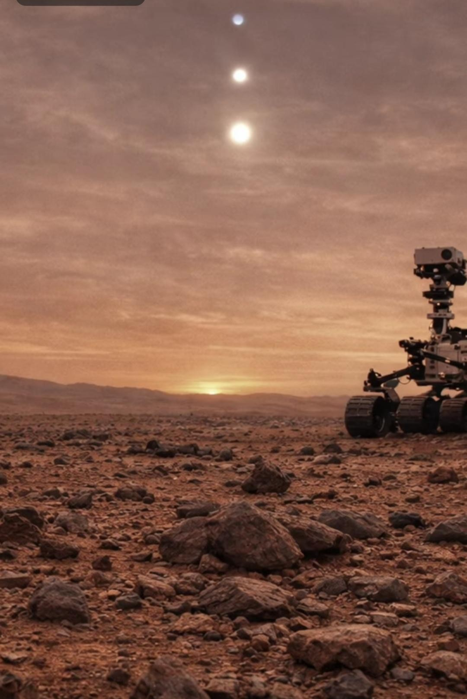
accepted

taxonomy.
budget

is

established.

“Psyhrrongian

slugs”

and

“hooda”

are

author-proposed

informal

names,

not
No

biological

identification,

life-cycle

transition,

movement,

reproduction,

or

usable

organism-scale

energy
Speculative—not

a

discovery

announcement.
2
ORCID

·

0009-0001-3697-319
Richard

Piesse

—

submitted

hypothesis
and

a

falsifiable

research

framework
Morphological

observations,

geological

alternatives,
A

Speculative

Lithobiological

Life

Cycle

on

Mars
The

Rock-Worm
T
N
E
M
I
R
E
P
X
E
T

H
G
U
O
H

T
C
I
F
I
T
N
E
I
C
S

D
E
AT
R
T
S
U
L
L
I

N
A
Abstract & contents READER’S GUIDE

Abstract & contents
This thought experiment imagines a previously unrecognized rock-associated system on Mars. An attached, cap-like hooda form would release mineralized clasts; rounded “pods” would undergo internal chemical reorganization; elongate “rock-worms” would emerge, seek favorable radiochemical or redox environments, and return to aggregate and recement into an attached stage. The proposed “Psyhrrongian slugs” would thereby connect ordinary-looking rocks into an exotic life cycle.
The supplied static images motivate questions, not biological identifications. Documented Martian mineralogy, aqueous alteration, sedimentary processes, and wind-driven sand transport provide environmental context. They do not establish the proposed sensory organs, metabolism, locomotion, communal behavior, or heredity. This report preserves the imaginative sequence while testing its assumptions against geological alternatives and physical constraints.
Evidence boundary. No linked life-cycle transitions or organism-scale energy budget have been demonstrated. None of the image plates should be read as authenticated evidence of Martian organisms. Narrative coherence is not demonstrated thermodynamic or evolutionary viability.

Contents
1 · Established geological context 3
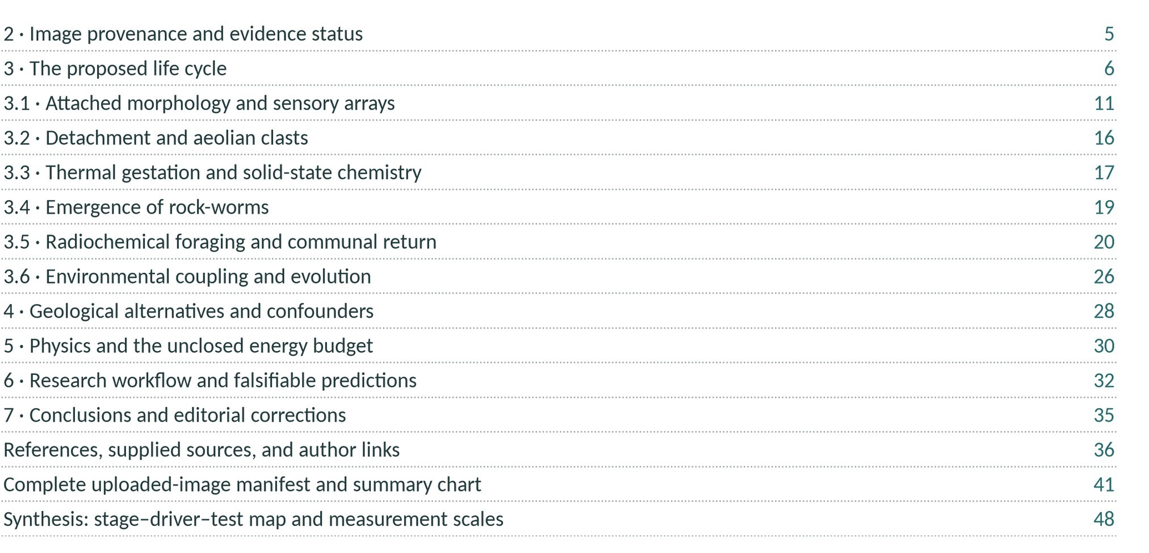
Editorial edition: the conceptual substance and sequence are preserved, but the text is reorganized and scientifically qualified. This is not a verbatim facsimile of the submitted draft. Image plates appear throughout; all source IDs are retained in the manifest.
Geological context
·
1 WHAT THE LITERATURE ESTABLISHES

Setting the Martian stage
Mars presents a cold, low-pressure, irradiated surface, yet its rocks preserve a diverse record of water–rock interaction. Hydrated minerals, iron oxides, sedimentary strata, and mineralized fractures motivate investigations of past habitability and preservation. Liquid water and possible brines are relevant to this history. Liquid helium, suggested parenthetically in the submitted draft, is not an alternative aqueous medium: its cryogenic requirements are unlike the ancient Martian surface environments under discussion.
Three rover settings must remain distinct. Opportunity investigated spherules at Meridiani Planum; Curiosity explores the sedimentary succession, dunes, and fractures of Gale crater; Perseverance investigates Jezero crater. Evidence from one landing site cannot establish the chemistry, origin, or location of an unverified image from another —or of a screenshot with no mission metadata.

Meridiani: mineral spherules, not established eggs
NASA/JPL’s account of Opportunity’s “Berry Bowl” analysis reports that Mössbauer spectroscopy identified hematite as the major iron-bearing mineral in analyzed spherule accumulations. The BB-sized, millimetric “blueberries” occur embedded in outcrop and scattered on soil. Interlocking spherules and their distribution within rock favor concretion growth in water-soaked deposits, followed by release through erosion. This is a geological interpretation supported by instrument and field context, not a demonstration of cocoons or eggs. It does not establish hematite in every rounded object in the supplied pictures. [R1]

Gale: depositional and diagenetic complexity
The Sutton Island study describes a complex depositional and alteration history using Mastcam multispectral information and supporting chemistry. Its abstract reports spectra consistent with Fe-smectites and discusses water– rock interactions in a possible nearshore or low-stand setting. The Maria Gordon notch study interprets fracture networks in terms of burial, dewatering, sulfate mineralization, and exhumation, with implications for the duration of habitable conditions. These are environmental and geological findings—not observations of a lithic life cycle. For both sources, this edition checked metadata and abstracts rather than publisher full texts. [R4] [R5]

Jezero: distinguish crater floor from delta
Bell and colleagues’ first-year Perseverance imaging study describes primarily igneous Máaz and Séítah crater-floor rocks, lightly altered by water, with pyroxene, olivine, and secondary crystalline hematite. The delta is sedimentary, but the study found no compelling evidence for lacustrine sedimentation on the explored crater floor. It did not establish organisms. Describing every explored Jezero unit as mudstone would therefore misrepresent the source. [R2]
Environmental opportunity is not evidence of occupancy. Porosity, mineral diversity, and an aqueous history make useful astrobiological targets. Connecting them to the proposed rock-worm requires additional, independent evidence.
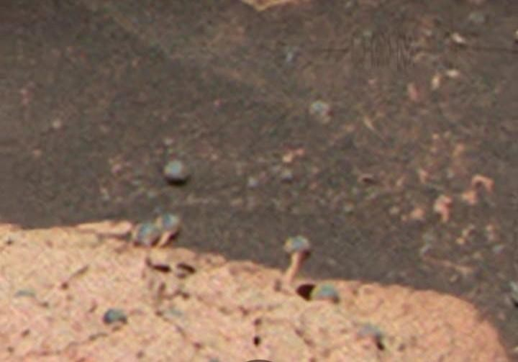
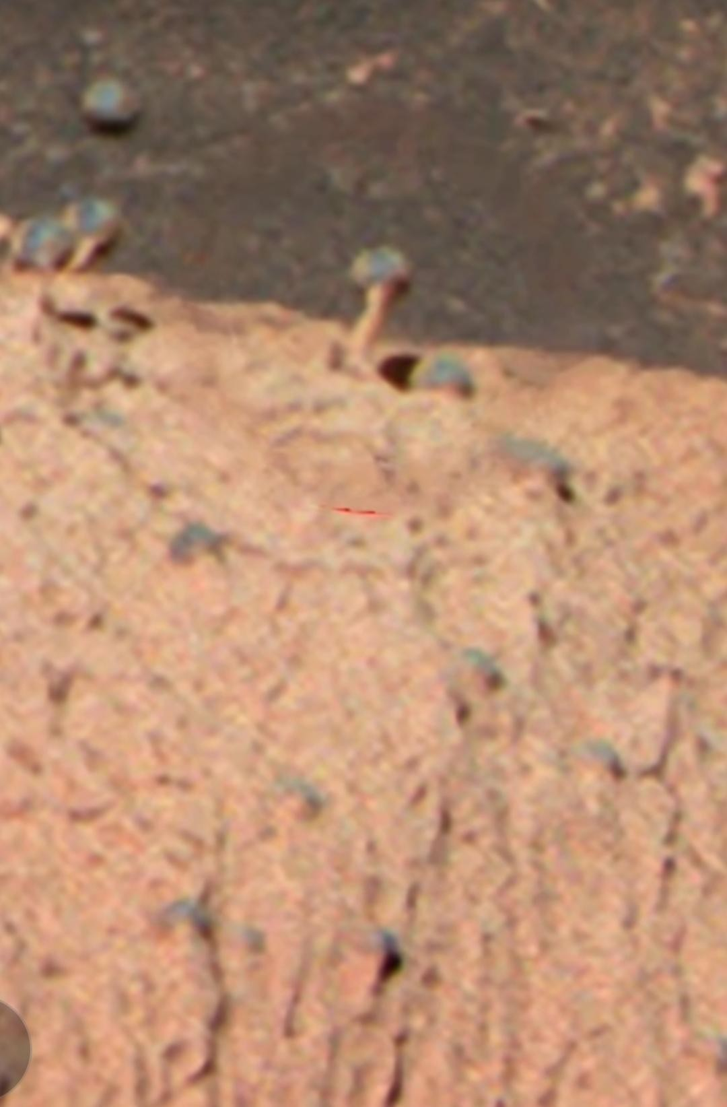
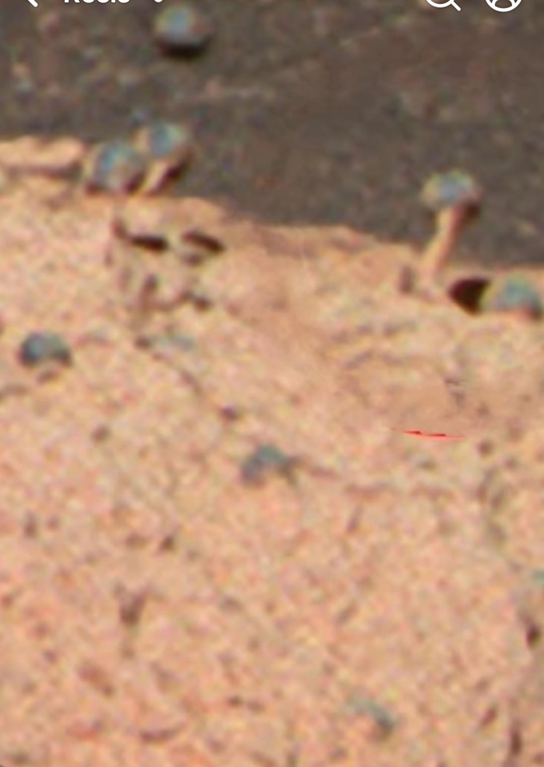
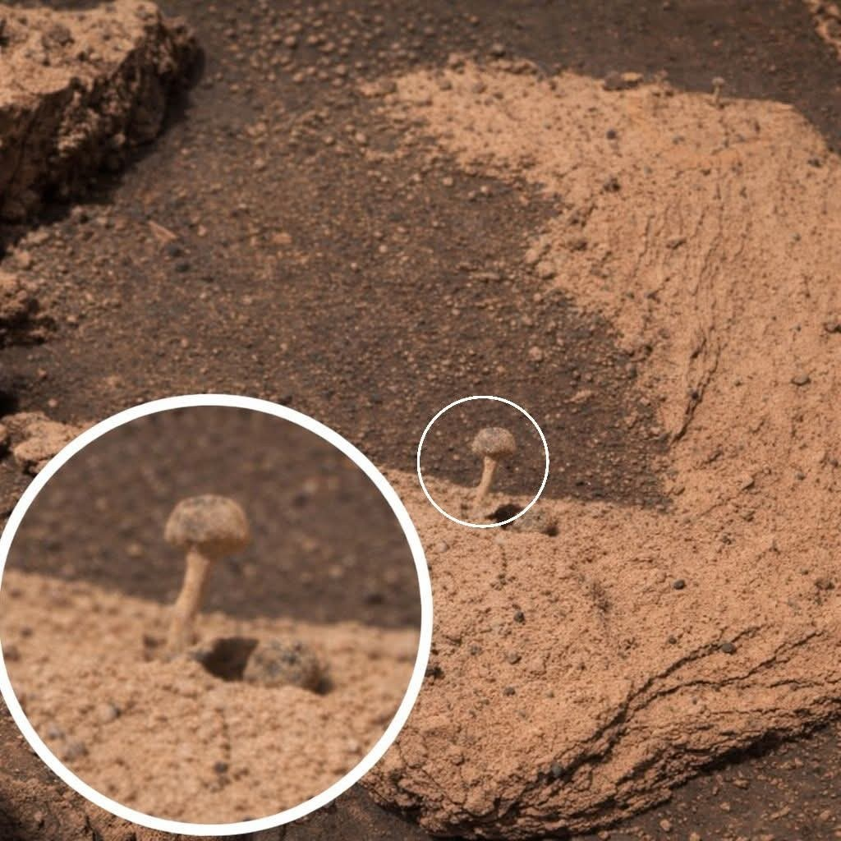

Provenance & evidence
2 WHAT THE PICTURES CAN AND CANNOT SHOW

Image provenance and method
This is an editorial analysis of visible forms, not an authenticated mission-image survey or measured morphometric study. Supplied file IDs are retained. Images are resized without generative alteration; annotations, insets, interface elements, and displayed credits remain part of the supplied record. Repeated crops, enlargements, and collage panels are not independent specimens.
Required field | Availability in the supplied record
Original mission archive ID, camera, sol | [DATA NOT AVAILABLE]
Physical scale, viewing geometry, edit history | [DATA NOT AVAILABLE]
Registered same-object repeat imaging | Not supplied; related crops do not constitute a time series.
Composition, orientation, sampled population | Not measured for the pictured objects.
No preferred azimuth, growth rate, transformation, or population frequency can be inferred from this selected collection. Bedding, lighting, perspective, compression, and selection all affect appearance. “Mushroom,” “skull,” “egg,” and “worm” are descriptive analogies, not classifications.
Question or process | Documented general process | Available in supplied imagery | Biological  mechanism
Aqueous alteration | D · literature | U · local history | N
Sand transport / abrasion | D · literature | U · local action | N
Individual image provenance | Not applicable | M | Not applicable
Screenshot morphology | Not applicable | V | N
Preferred orientation | N · here | U | N
Directed movement / hatching | N · here | U | N
Radioelement enrichment at objects | N · here | U | N
ELF sensing / hive signaling | N · here | U | N
Replication / heredity | N · here | U | N
Figure 2 · Evidence-status matrix. D = documented in contextual literature; V = visible shape only; M = missing provenance; U = unmeasured; N = not established for this proposal. Categories are not scores, probabilities, or an ordinal scale. Documented environmental processes do not validate the biological column.
Conceptual life cycle
3 A MODEL TO BE TESTED

The proposed life cycle
The submitted hypothesis connects several familiar-looking mineral forms into an unfamiliar biological story. An attached cap-and-outgrowth array is imagined as an adult or communal structure. Detached fragments would become transported clasts, rounded “pods,” and eventually elongate foragers. Their proposed return and re-cementation would close the cycle. The names hooda and “Psyhrrongian slugs” distinguish imagined stages; they have no accepted taxonomic standing.
Dashed

arrows

represent

conjecture,

not

measured

transformations.
Null:

cementation
re-cementation
Proposed

aggregation

/
Null:

passive

displacement
Hypothetical

forager
Null:

fracture

release
Hypothetical

emergence
Null:

concretion

growth
Rounded

“pod”
Null:

spalling
Hypothetical

detached

clast
Null:

differential

erosion
Attached

mineral-like

array
Conceptual

model;

no

transitions

observed
Figure 1 · Six-stage conceptual cycle. Icons are technical abstractions, not reconstructions of authenticated organisms. Geological alternatives are paired with stages to prevent the cycle from being mistaken for an observed sequence
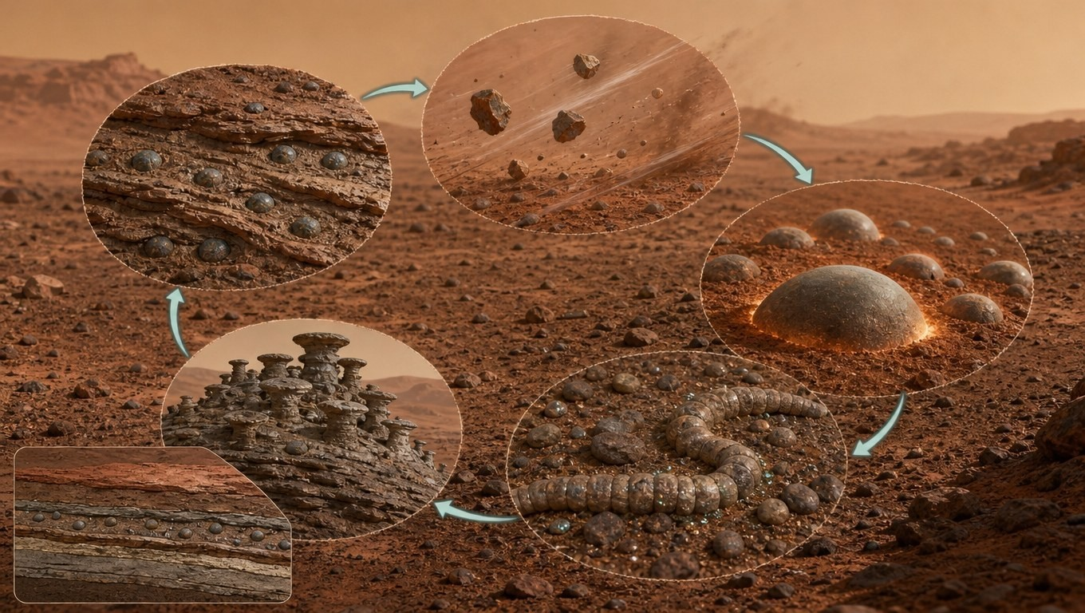
Figure 9 · Artist’s conception of the proposed cycle. Clockwise from top left: hematite-cored “Martian berry” in strata → larval clasts lifted by saltation → thermally cycled pods → elongate rock-worms near radioactive grains → re-cemented hive array. AI-generated illustration for orientation only; it is not mission imagery or evidence.
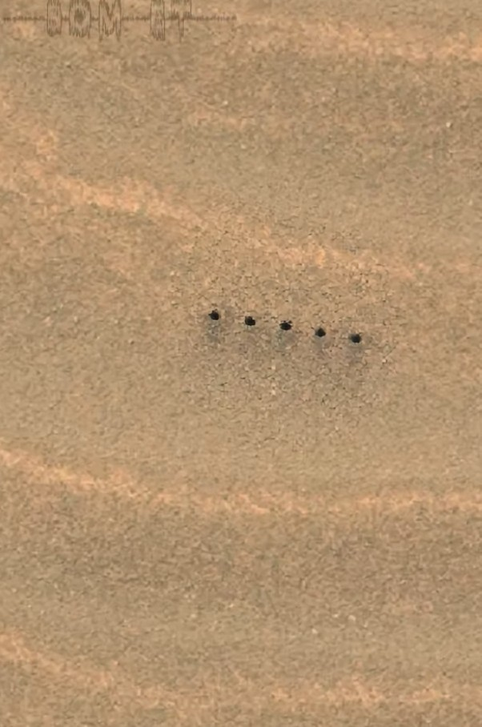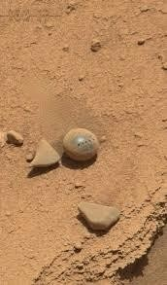
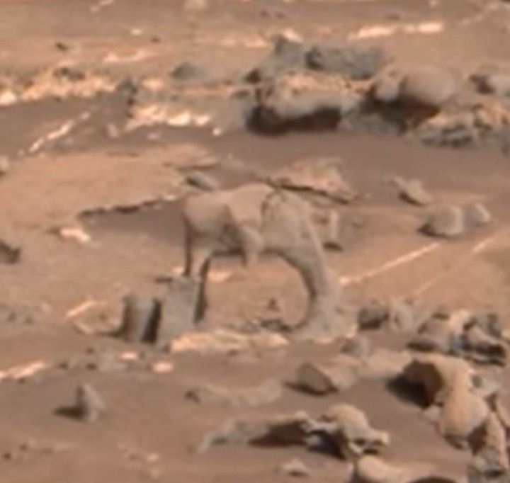
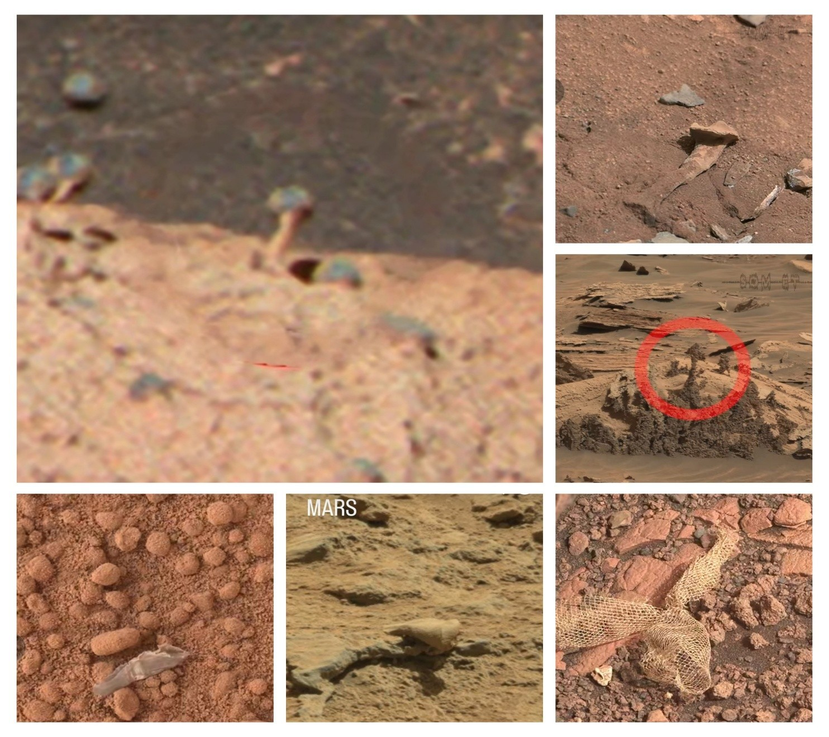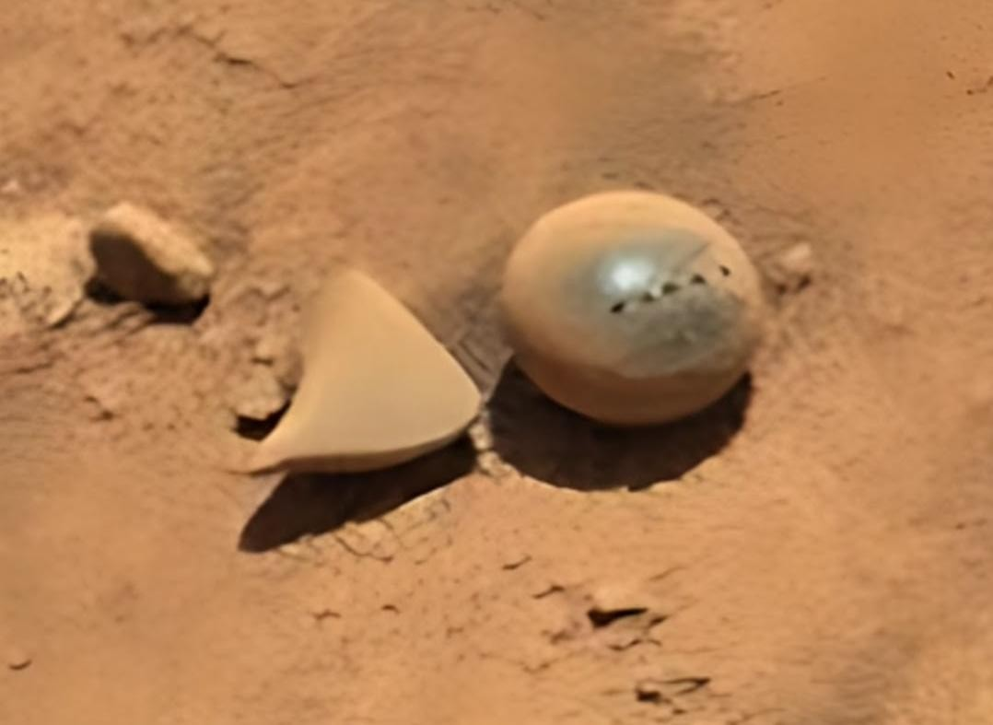
.
A linked cycle is a stronger claim than a collection of similar shapes. It requires evidence that a particular object changes state, that material and energy flow through those states, and that the system reproduces with inherited variation. No supplied image establishes such a connection. Consequently, every transition in Figure 1 remains conjectural, even where a proposed stage resembles a documented mineral form.
The following sections develop the author’s narrative conditionally. Each preserves the proposed function while identifying what would have to be measured for it to become a physical or biological explanation rather than a visual analogy.
Hooda & sensory conjectures
3.1 ATTACHED MORPHOLOGY

The hooda and its proposed sensory array
The imagined starting unit is a small cap-like structure with adjacent triangular or horn-like outgrowths, perched on or partly exposed from a host rock. The submitted manuscript compares this composite with a bat’s head and “mandibles.” These expressions convey an impression of form; they do not establish appendages, anatomy, or a unified organism. The pedestal and nodular appearances in Figure 5 provide visual prompts for the thought experiment, not an anatomical series.
Within the hypothesis, a hooda would function as an attached sensory array. Conical elements might resonate mechanically and couple stress into a mineral network. Substrate-borne elastic vibrations, perhaps associated with granular motion or thermal changes, would be one possible stimulus. Electromagnetic fluctuations would be another. These are different physical channels and would require separate source, transmission, and detection models.

Sound, ultrasound, and ELF are not synonyms
Ultrasound is mechanical sound above 20 kHz. Low-frequency elastic vibrations are not ultrasound, and extremely lowfrequency electromagnetic fields are not sound. A signal propagating through solid regolith also couples differently from a pressure wave in a thin atmosphere. The proposed organism cannot be said to “use ultrasound” merely because an object has a cap or a pointed lobe. No frequency response, resonant mode, receptor, or stimuluslinked response has been measured in these objects.
The mineral-transducer idea is best expressed as a conditional materials hypothesis. A suitable mineral phase, with the necessary symmetry, orientation, and connected structure, could in principle convert stress into electrical polarization. Piezoelectric behavior is phase-dependent: neither “silicate” nor “iron oxide” guarantees it. A hematite identification alone would not demonstrate piezoelectric sensing, and the pictured objects do not have even that compositional measurement. Semiconductor-like phases embedded in an organized sensory network are additional conjectures, not observed features.

Orientation would need an independent survey
The original suggestion of similarly canted “mandibles” is retained only as a question. There are no calibrated threedimensional orientations, unbiased population samples, or local environmental vectors with which to compare them. Bedding, jointing, erosion direction, illumination, camera geometry, and image selection could all generate apparent alignment. Repeated crops cannot supply the missing independent observations.
Plant phototropism and magnetotactic bacteria offer analogies for directional response, but they do not provide evidence for this system. To test mineral sensing, investigators would need to identify a reproducible signal, a physically credible coupling pathway, and a response exceeding matched passive-material behavior. Source strength, signal-to-noise ratio, attenuation, and the cost of responding would all matter.
Sensing is not an energy budget. Detecting a weak perturbation, converting mechanical stress into charge, and harvesting enough free energy to maintain an organism are distinct propositions. Demonstrating one would not establish the others.

Mapping the proposed signal channels
The hooda narrative invokes several stimuli at once. Figure 10 separates them by physical channel. Perseverance’s SuperCam microphone has recorded the Martian soundscape between roughly 20 Hz and 50 kHz and found that sound travels at about 240 m/s at low frequencies and about 250 m/s at higher frequencies, compared with about 343 m/s in Earth’s air. The thin CO₂ atmosphere strongly attenuates high frequencies, so an airborne ultrasound channel would be short-range at best. Substrate-borne elastic waves and ELF electromagnetic fields are different physical problems and need their own source and detector models. [R16]
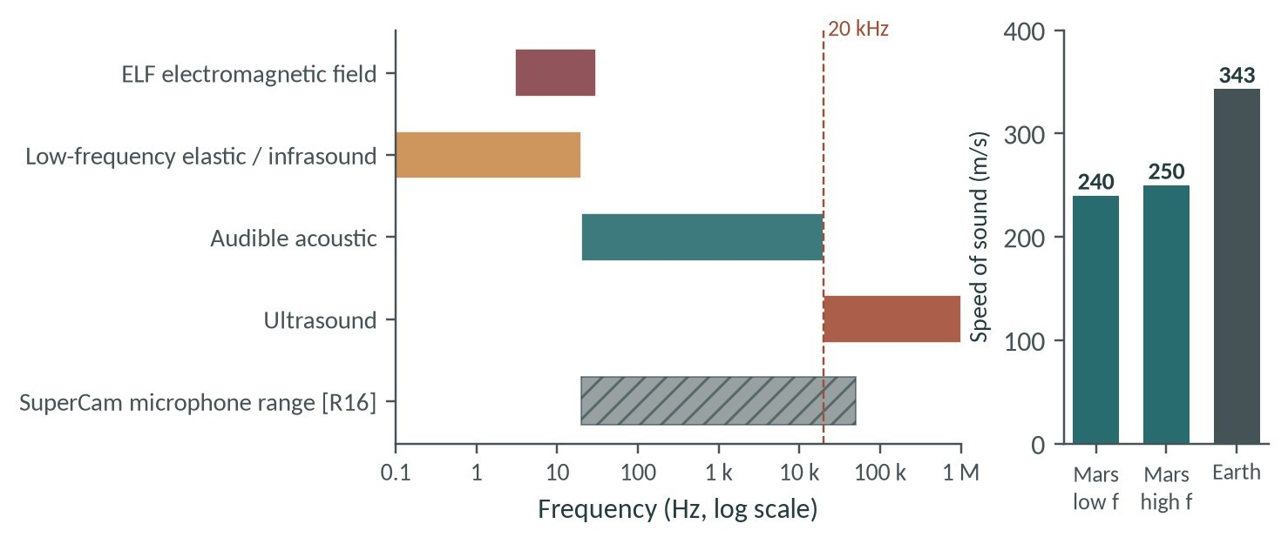
Figure 10 · Candidate sensing channels for a hooda. Left: nominal frequency bands (log scale); the dashed line marks the 20 kHz ultrasound boundary and the hatched bar the SuperCam microphone’s recorded range. Right: measured speed of sound on Mars versus Earth. ELF fields are electromagnetic, not acoustic, despite sharing the frequency axis. [R16]
Test that follows. Place matched inert clasts and candidate hooda forms under the same controlled vibration or field and compare frequency response. A biological transducer predicts a response beyond passive resonance; a mineral predicts none.
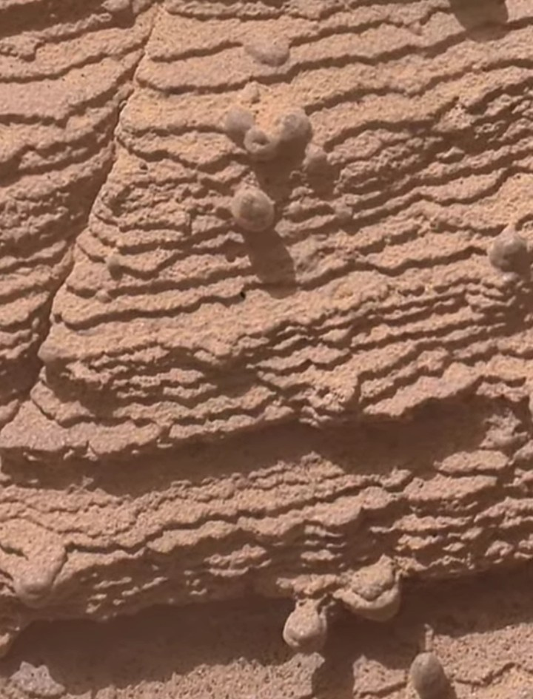
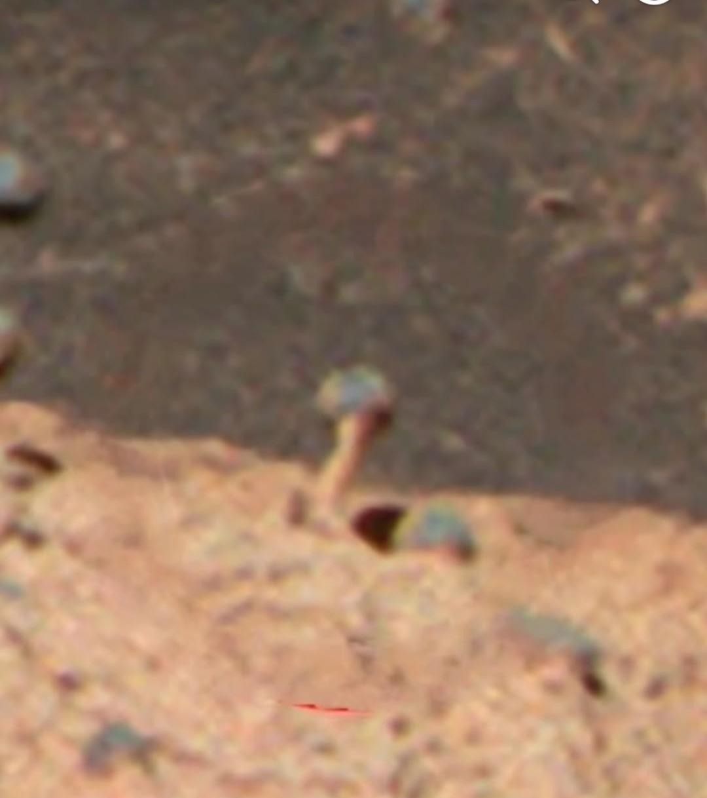

Plate A · caps & nodules
OBSERVATION VERSUS INTERPRETATION · PLATE A

Caps, pedestals, and nodules
Visible forms can motivate a question without identifying a living structure.

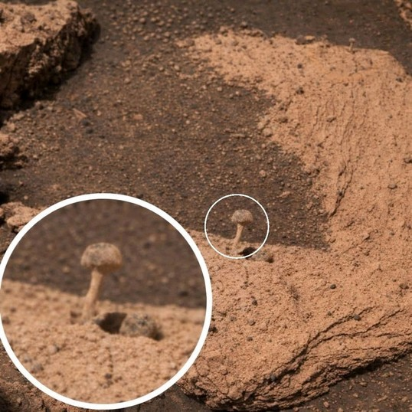
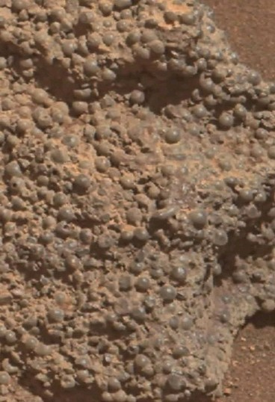
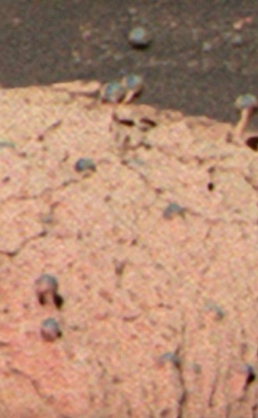
02 · WyhOfyJv
Observation: A cap-like protrusion is highlighted by circular annotation and an enlarged inset.
Hypothesis: An attached hooda sensory stage.
Alternative: Differential erosion around a resistant nodule or cemented feature.
The inset repeats the same feature. No scale, composition, or mission provenance is established.

03 · jCHT8cWF
Observation: Numerous rounded protrusions occur in a textured matrix.
Hypothesis: A population of mineralized attached stages.
Alternative: Nodular cementation, concretion formation, and differential weathering.
Visual resemblance does not establish hematite, independent organisms, or a measured population.

05 · Xh0XgeRD
Observation: Small, dark cap-and-stalk-like forms appear beside a layered surface.
Hypothesis: Repeated hooda structures with functional geometry.
Alternative: Erosion-resistant protrusions shaped by local rock fabric.
Low resolution and missing viewing geometry preclude orientation or anatomical measurements.
Figure 5 · Plate A. User-supplied images, resized without generative alteration. Original provenance is unverified. “Observation” describes visible appearance; proposed function and geological alternatives are not established diagnoses. Related views elsewhere in the upload collection are not independent confirmations.
No panel shows a stimulus response or a transition to another stage. An attached-looking form is not, by itself, evidence of attachment by a living organism.
Detachment & transport
3.2 DETACHMENT AND DISPERSAL

From attached form to mobile clast
In the proposed cycle, a mature hooda would fracture along a mineral seam, releasing its cap and associated outgrowths onto a nearby slope. The liberated piece would be the model’s “larval clast.” This preserves the submitted idea of a mineralized organism using the physical environment for dispersal, while leaving developmental control unproven. No pictured source structure is tracked through breakage into an identified descendant fragment.
Ordinary rocks already detach along joints, bedding surfaces, cement boundaries, and fatigue cracks. Calling a weakness plane “programmed” or “pre-engineered” adds a claim about organized development that a fracture photograph cannot support. A biological seam would need to differ reproducibly from passive fracture patterns, perhaps in its formation, composition, timing, or relationship to an independently demonstrated reproductive process.

Wind provides context, not unlimited transport
Curiosity’s Bagnold Dunes observations document active Martian sand processes, including ripples, grainfall, and grainflow. This is a sound contextual basis for considering wind-driven transport and abrasion. It is not evidence that modest gusts can mobilize arbitrary pebble-sized, dense fragments. The checked abstract concerns dune sedimentary processes; it does not validate the proposed larval transport mechanism. [R6; abstract checked]
Whether an individual clast could roll, slide, or remain fixed depends on its size, density, shape, surface contact, cohesion, slope, and the applied aerodynamic stress. These quantities are unmeasured for the supplied objects. A shape might influence torque if a transport threshold were reached, but this does not demonstrate that the geometry evolved for wind dispersal. Selection is a biological inference requiring evidence of reproduction and inherited variation, not merely a mechanically interesting form.

Rounding does not establish a pod
The narrative imagines repeated storms and impacts gradually removing sharp edges until transported fragments become nearly spherical “pods” or “eggs.” Abrasion can modify clasts, but a round object need not have acquired its shape by tumbling. Concretions can grow approximately round within sediment, and erosion can later release them into a surface lag. Opportunity’s spherules supply a clear reason not to treat roundness as evidence of developmental encapsulation. [R1]
Nor is roundness, by itself, a demonstrated minimum-energy endpoint for this proposed organism. Geometry depends on growth, material properties, stress, and erosion history. The polished-looking sphere-and-fragment image in Figure 7 requires source verification before even those geological questions can be addressed. It cannot connect an attached form to a mature pod.
Missing link: A persuasive detachment sequence would follow the same parent feature and released fragment through registered repeat images, with material correspondence and environmental controls. Similar shapes in separate pictures are not a lineage.
Thermal chemistry
3.3 INTERNAL CHANGE IN A MINERALIZED POD

Thermal gestation: a chemical conjecture
Martian near-surface materials experience changing thermal conditions over a sol. The hypothesis imagines a detached pod being jostled by granular motion and warmed and cooled within the regolith. Thermal expansion, volatile redistribution, and grain-boundary reactions could alter a porous mineral body. Calling these changes “gestation,” however, requires evidence of organized development rather than weathering, cementation, or damage.
T*

=

sin(2πφ

−

π/2)
s
t
i
n
u

d
e
z
i
l
a
m
r
o
n

y
r
a
r
t
i
b
r
a

·

*
T
Fraction

of

a

Martian

sol,

φ
1
0.75
0.5
0.25
0
−1
0
+1
MATHEMATICAL

SCHEMATIC

—

NOT

ROVER

DATA
Figure 3 · Pedagogical idealization. The displayed sinusoid is a mathematical schematic, not rover data, a calibrated surface/subsurface model, or evidence of incubation. Its coordinates are normalized mathematical values; no physical temperatures are inferred.
Inside a hypothetical pod, inherited pores might contain adsorbed gases, hydrous phases, or transient brines. None has been measured here. Perchlorate residues would not, by themselves, establish an available solvent or a habitable reservoir. Reaction usefulness would depend on accessible reactants, kinetics, sustained disequilibrium, and the retention of products rather than their recombination or loss.
The more exotic proposal is a radiation-assisted “solid-state metabolism”: catalytic mineral surfaces and mixedvalence iron oxides or silicates would reorganize organic or organometallic material into an informational substrate. This is a substantial leap from possible mineral chemistry. A lattice defect is not a demonstrated genome; a cortex is not a demonstrated membrane. An informational system would need copying, persistent variation, repair, and coupling to usable free energy.
Irradiation can drive reactions and also destroy organic molecules. Repeated heating and cooling does not automatically rectify energy into useful biological work. No chemical pathway, internal contents, actual temperature history, or developmental change is established for the pictured objects. The thermal scenario remains a proposal for controlled
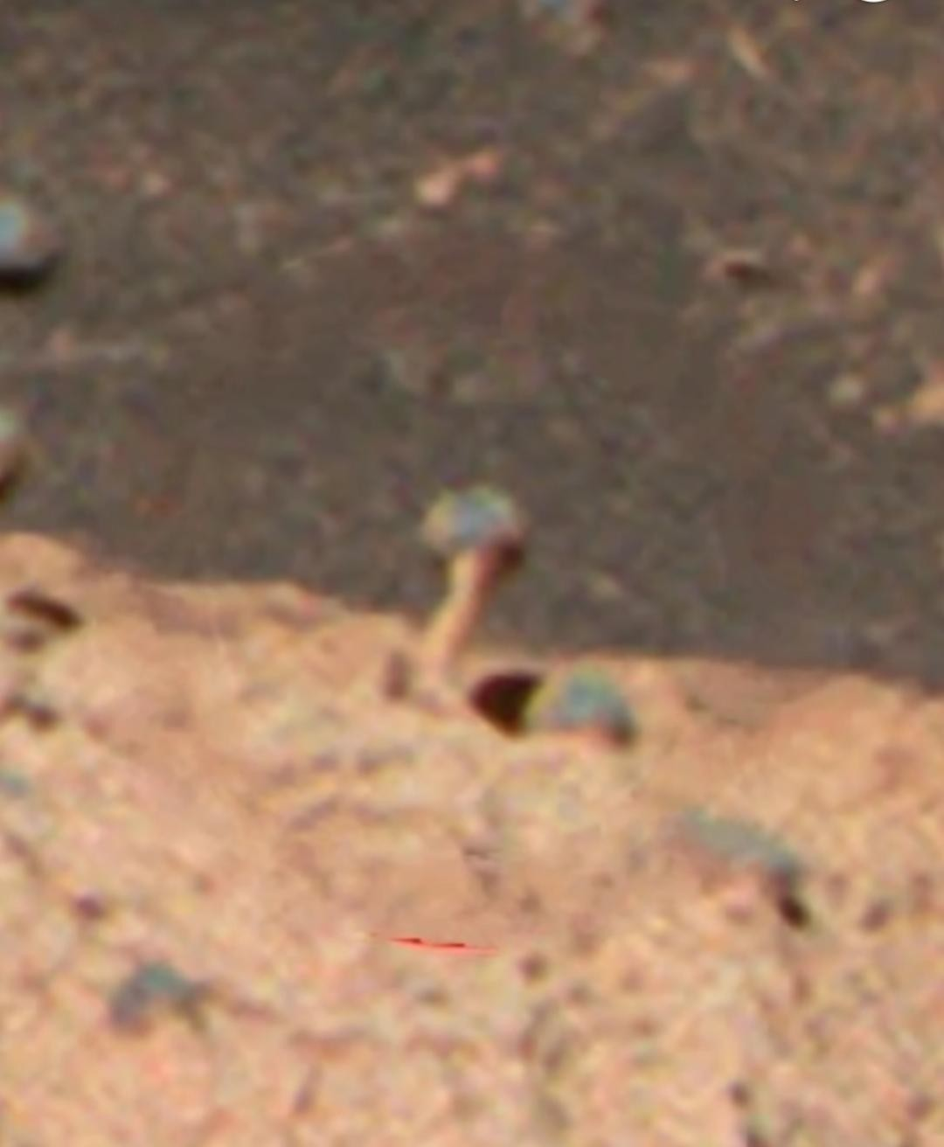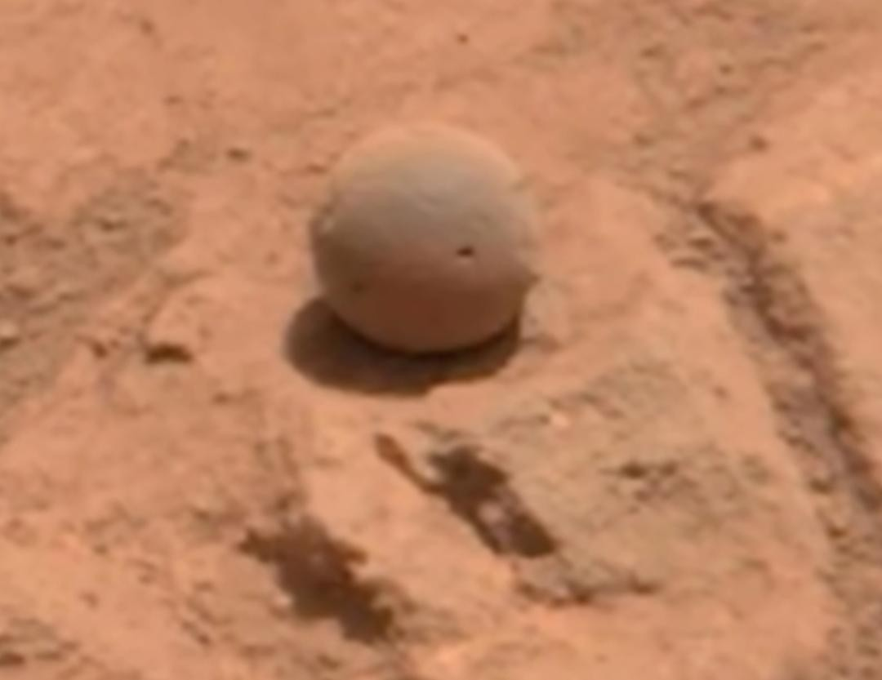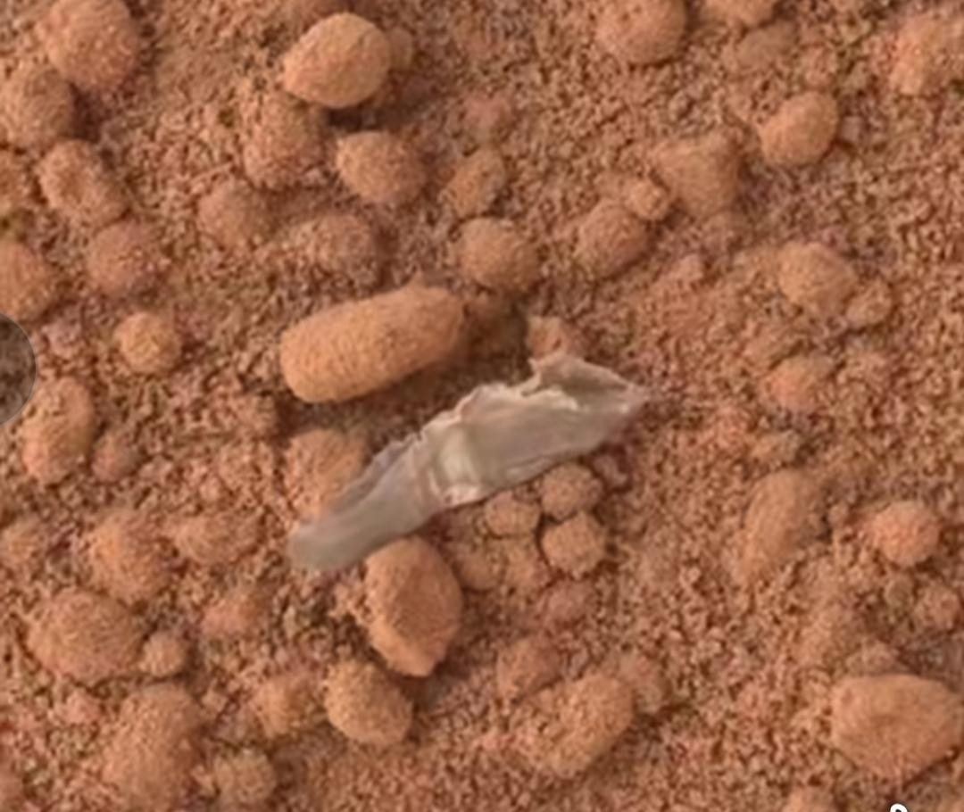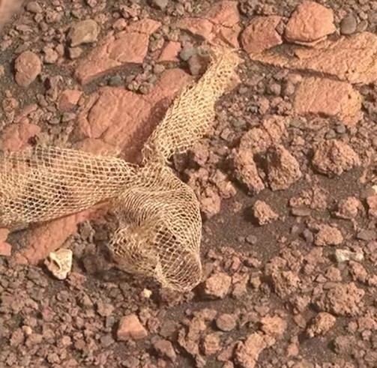
materials experiments, not an observation of gestation.
Hypothetical emergence
3.4 EMERGENCE AND MOVEMENT

The imagined rock-worm stage
Once sufficient internal reorganization had occurred, the model’s pod would split along a weakness plane and release an elongate, slug-like form into spaces between regolith grains. These “Psyhrrongian slugs” would be difficult to distinguish visually from small fragments of rock. Their mineral-like exterior would be part of the proposed adaptation, not evidence that every unusual clast belongs to the system.
No supplied image records hatching or demonstrates that an elongate form came from a rounded precursor. Fracture release, mineral veins, crystal casts, cemented ridges, and ordinary fragments can create superficially comparable shapes. The sinuous ridge in Figure 6 is an appearance on a slab, not an observed organism moving across it. The asphalt-like comparison in Figure 8 has no Martian provenance and is not assigned a species here.

A motor cannot be supplied by analogy alone
The original manuscript proposes locomotion through ratcheting microfractures and grain-scale rearrangements, comparing it with creep but on imagined biological timescales. That analogy does not demonstrate a motor. A viable mechanism would have to generate directed displacement while accounting for friction, required forces, energy supply, repair, and the irreversible damage caused by repeated fracture.
Passive creep, settling, wind disturbance, and thermal expansion would need to be measured in matched controls. A changing shadow, camera viewpoint, exposure, or dust cover is not displacement. The months or years contemplated in the submitted narrative are hypothetical timescales, not measured rates, and no numerical velocity is assigned in this edition.

A mineral cortex and radiochemical microenvironment
A hematite-rich “skin” is retained as a proposed protective cortex, by analogy with the iron-bearing spherules investigated at Meridiani. Neither its composition nor its organization has been measured in these pictures. Ironbearing phases might participate in redox chemistry if suitable partners and conditions existed, but density, hardness, and abrasion resistance do not establish metabolism. [R1; geological analogy only]
The hypothesis further imagines uranium- and thorium-bearing accessory minerals concentrated inside that cortex. Their natural decay might, under suitable conditions, drive radiolysis of adjacent hydrous material or ice. Such a reaction microenvironment would still require accessible reactants, product separation, and energy capture. No local enrichment, dose, reaction product, or coupling efficiency is supplied.
Decay is not a fission reactor. Natural radioactive decay and radiolysis must not be conflated with a selfsustaining nuclear chain reaction. If the term “micro-reactor” is used in this narrative, it means only a hypothetical chemical reaction microenvironment. No Martian natural nuclear reactor is adopted as evidence.
Foraging & communal return
3.5 RADIOCHEMICAL ECOLOGY

Foraging, storage, and return to a “hive”
The proposed rock-worm would search the upper regolith for favorable gradients in radiation or redox potential. A heavy-mineral lag, fracture-associated deposit, potassium-bearing feldspathic material, or uranium-bearing accessory mineral supplies the narrative with a possible resource patch. These possibilities do not establish a measured enrichment at any pictured object. There are no object-level potassium, uranium, or thorium assays, and no statistical sample supports the original suggestion of significant local enrichment.
The ant-foraging analogy makes the ecological story intelligible: a mobile form would leave an aggregate, seek resources, and return with material or stored energy. It does not provide a detection mechanism. The hypothesis requires a directional signal strong enough to distinguish favorable locations from background variation and noise, as well as a way to convert that signal into movement.
What would a radiation gradient mean?
Proposed gamma- or neutron-field sensing is unmeasured. Neutron signals reflect particle production, transport, and surrounding composition, including hydrogen; they are not necessarily a radioelement-specific beacon. A useful detector would require an appropriate response, spatial discrimination, calibration, and a noise model. No such structure or response is visible in the static pictures.
Similarly, radioactive decay is not itself a coherent ELF communication source. A proposed link between electrochemical activity, mechanical resonance, and electromagnetic signaling would need a quantitative source and coupling mechanism. It cannot be supplied simply by using “ELF” as a common label for unrelated phenomena. Any sensory advantage would also have to exceed the costs of maintaining the detector and acting on its output.

From radiolysis to usable work
If radiation produced oxidants and reductants within or near a mineral body, the model would still need to separate and exploit them. Available power would depend on incident or internal energy deposition, reaction yields, phase accessibility, diffusion, competing reactions, recombination, and losses. The suggested storage of energy in metastable lattice defects or unusual charge configurations is a materials conjecture, not evidence that energy has been biologically harvested.
Finally, the narrative proposes that resource-rich foragers return to their natal outcrop or an equivalent “hive.” Collective piezoelectric vibrations and ELF beacons would guide them; re-mineralization would cement them into fresh attached arrays and contribute enriched phases to the communal reservoir. This preserves the manuscript’s distinctive ecological loop, but every behavioral element remains unsupported. Source strength, communication range, detection, navigation, and the costs of return have not been established.
A complete loop demands more than aggregation. Repeated directed departure and return, material transfer, and an inherited reproductive relationship would be needed. Ordinary cementation, passive accumulation, and mineral sorting can generate aggregates without a communal organism.

An order-of-magnitude energy check
The radiochemical story can be bounded with published numbers. Curiosity’s RAD instrument measured a galacticcosmic-ray absorbed dose of 0.21 ± 0.04 mGy per day at Gale crater [R14]. Odyssey’s gamma-ray spectrometer gives a global surface average of about 3300 ppm potassium and 0.62 ppm thorium [R15]. Applying standard radiogenic heatproduction constants, and assuming a chondritic Th/U ratio of about 3.8, a 10 g mineral body receives roughly 2 × 10⁻¹¹ W from cosmic rays and 4 × 10⁻¹³ W from its own average decay (Figure 11). These totals overlap the wide range of maintenance powers reported for laboratory microorganisms [R17]. The open question is therefore not raw supply. It is whether any mineral structure could capture a usable fraction of deposited energy faster than the same radiation damages it.
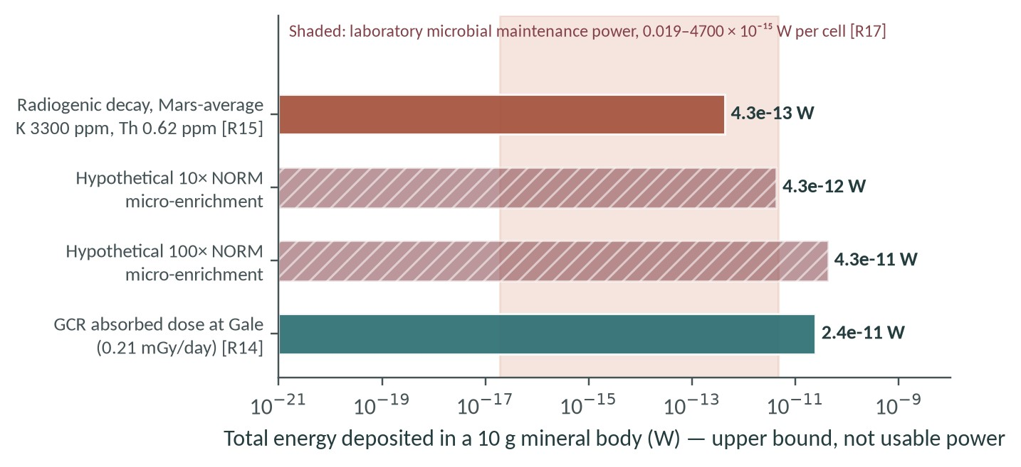
Figure 11 · Energy deposited in a hypothetical 10 g pod. Totals are upper bounds on deposited energy, not usable power: conversion efficiency η is unknown and damage is ignored. Hatched bars are hypothetical NORM micro-enrichments, not measurements. Shaded band: laboratory microbial maintenance power per cell. Sources: R14, R15, R17; U estimated from Th/U ≈ 3.8.
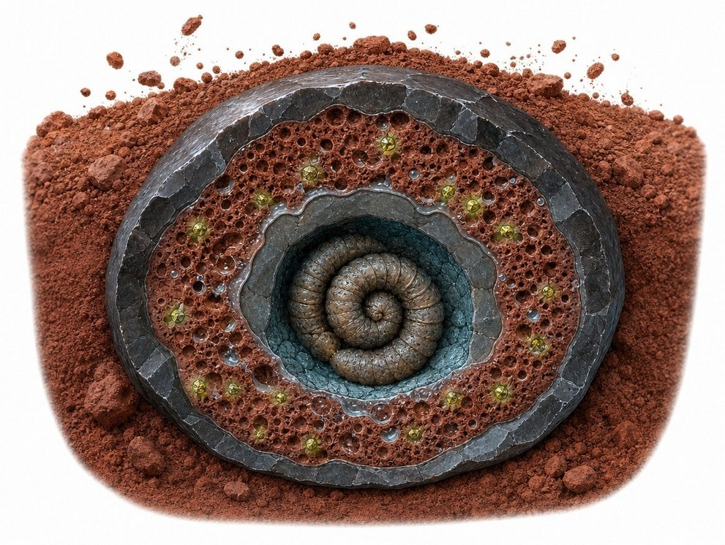
What would falsify the radiochemical pod. Micro-XRF mapping (PIXL-class, ~120 µm) of real Martian concretions that finds no K, Th or U enrichment in cortices relative to host rock, or laboratory irradiation of hematite-cortex analogues that yields damage but no stored, retrievable chemical energy, would remove the proposed power source for this stage.
Figure 12 · Conceptual cross-section of a pod. Proposed layers: dark hematite cortex, porous middle zone with possible ice or brine films, radioactive accessory grains (yellow-green) and a coiled rock-worm core. AI-generated concept art; no such interior has been observed.
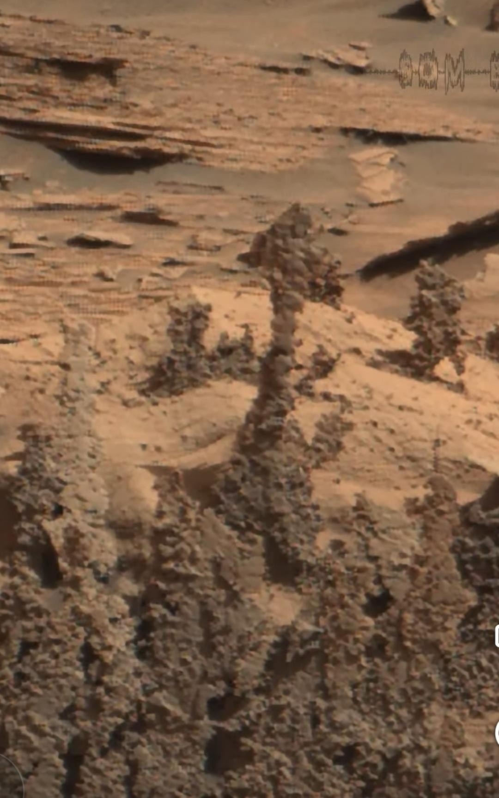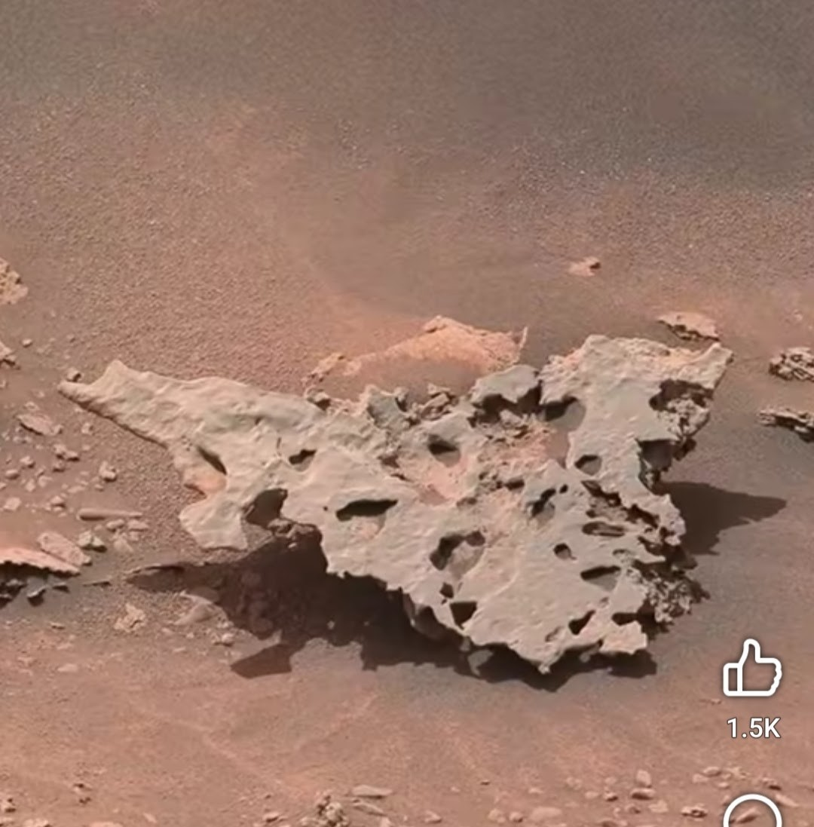
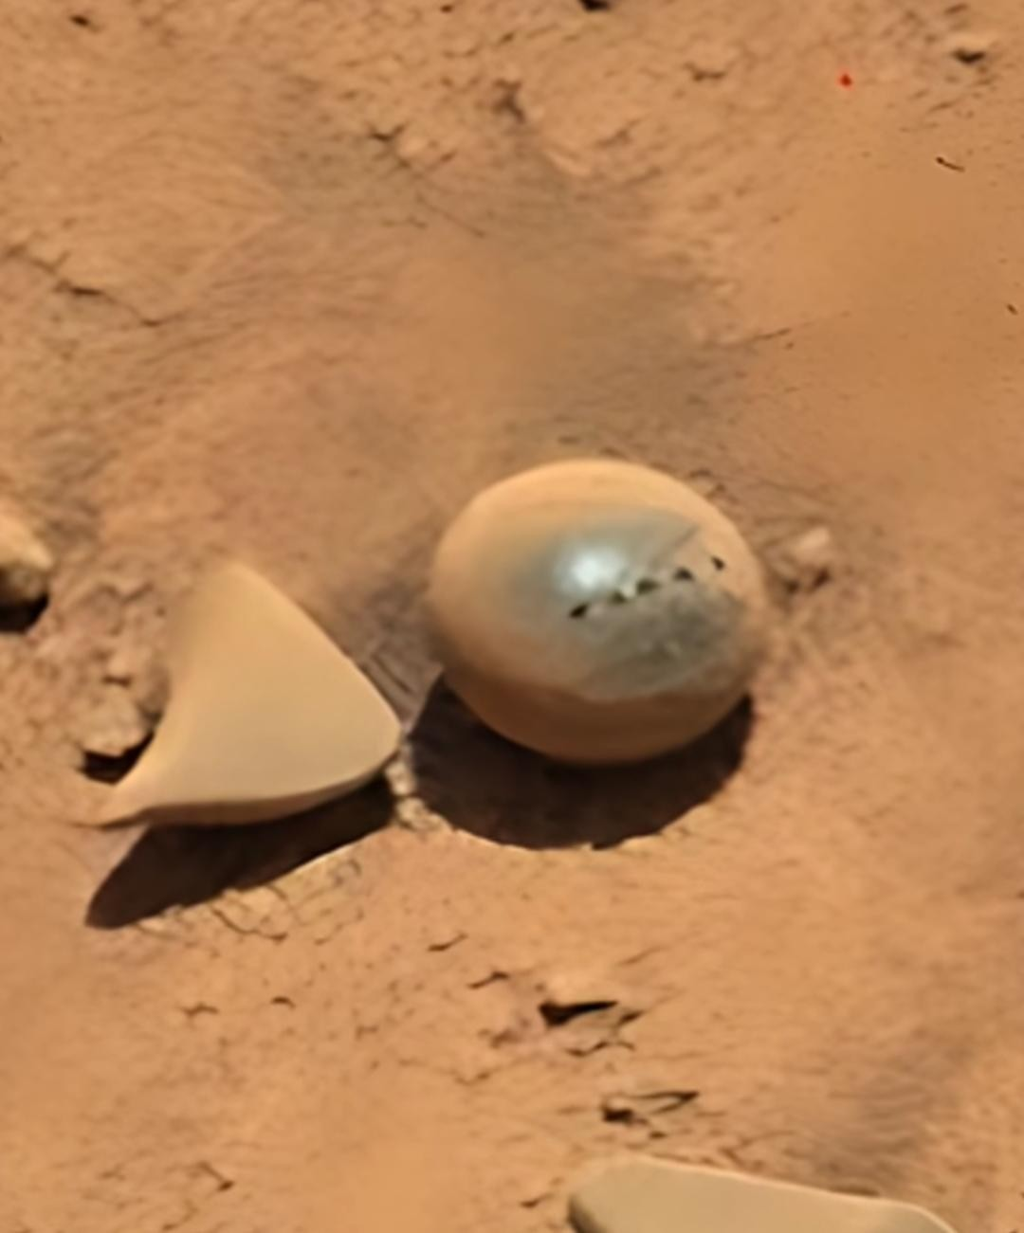

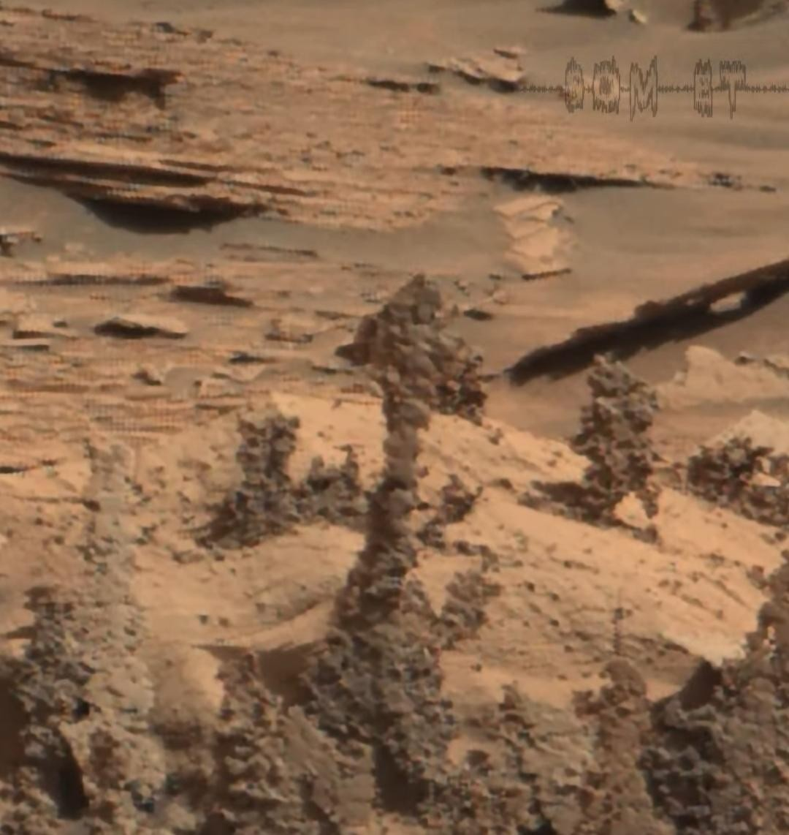
THE ROCK-WORM HYPOTHESIS
·

Evolutionary scenario
3.6 · ENVIRONMENTAL COUPLING

From mineral chemistry to “informational rock”
The hypothesis is most productive when its environmental motivations are separated from its biological conclusions. Three premises remain useful after qualification. First, wind-driven sand transport and abrasion are real Martian processes, although this does not mean that every dense clast is routinely mobilized. Second, igneous and sedimentary histories produce diverse mineral assemblages and potential redox opportunities, without establishing local radioactive enrichment in the submitted scenes. Third, ancient water circulation through porous rocks and fractures motivates questions about chemical reaction environments and preservation. [R1] [R2] [R5] [R6]
These premises permit an imaginative evolutionary bridge. Initially abiotic concretions or coatings might, in the story, acquire self-catalyzing mineral–organic films. Reaction networks could become associated with pore structure, and structural organization could become linked to energy capture and information persistence. The resulting system would be an “informational rock” rather than a familiar cell: structure, chemistry, and inheritance would be physically intertwined.

The missing evolutionary step
Self-catalysis alone is not heredity. A reaction that promotes more of itself does not necessarily copy a stable informationbearing organization, preserve variants, or generate descendants capable of further evolution. The model would need a mechanism for inherited variation, resource coupling, and differential replication. It must distinguish that mechanism from repetitive crystal growth, chemical patterning, and recurring physical conditions.
The absence of a familiar membrane or genome is not, by itself, a reason to reject every alternative chemistry. It is a reason to specify what performs their necessary functions: retaining components, regulating exchange, preserving information, repairing damage, and reproducing organization. Calling a lattice “genetic material” does not establish those functions. No validated nonaqueous solid-state biosphere follows from this proposal.

Why morphology remains ambiguous
Mineral growth and erosion can produce repeated shapes, boundaries, apparent symmetry, and distributions that invite biological analogies. A cap may resemble a mushroom; a ridge may resemble a worm; an angular fragment may resemble a jaw. Such resemblance can arise from physical convergence or pareidolia. It can guide target selection, but it cannot decide origin without compositional, temporal, contextual, and functional evidence.
The cap-to-pod-to-forager cycle is therefore a stylized end-member of a proposed mineral–organic continuum, not a reconstruction of an observed lineage. Its value lies in asking how an unfamiliar life system could become testable despite looking mineral-like. Its weakness is the number of unmeasured links between general environmental chemistry and an integrated organism.
Evolutionary plausibility requires a mechanism. A sequence of increasingly organized mineral forms is not evidence of Darwinian evolution unless organization is copied with persistent variation and differential replication.
Plate B · geological textures
OBSERVATION VERSUS INTERPRETATION · PLATE B

Strata, ridges, and cavities
Geological texture supplies strong alternatives before biological function is invoked.

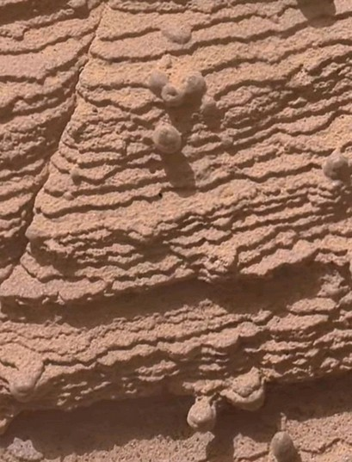
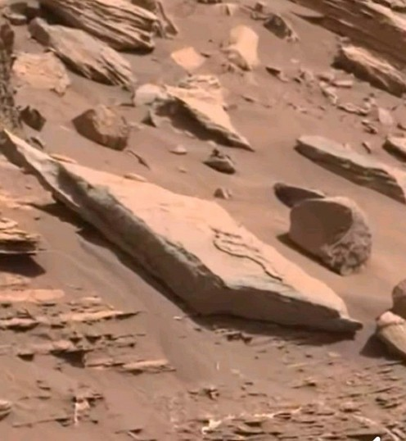
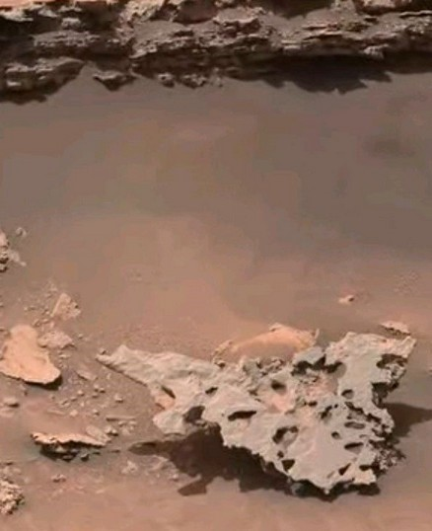
07 · pPyBmINi
Observation: Fine layers and rounded protrusions occur together.
Hypothesis: Attached stages occupy a host rock.
Alternative: Resistant nodules or cemented patches exposed by differential erosion.
No host–organism interface, composition, or geographic setting is authenticated.

12 · bQiTEtX7
Observation: A winding raised feature follows the surface of a slab.
Hypothesis: A rock-worm-like form or trace.
Alternative: A cemented ridge, vein-related relief, or other weathered rock fabric.
A sinuous outline does not demonstrate flexibility, movement, a body, or a trace fossil.

13 · TeCpzAja
Observation: An irregular surface contains conspicuous holes and cavities.
Hypothesis: An organized porous lithic structure.
Alternative: Weathering cavities, vesicular texture, dissolution, or heterogeneous resistance.
Cavities are not demonstrated cells, channels, or evidence of biological construction.
Figure 6 · Plate B. User-supplied images, resized without generative alteration; provenance and scale are unverified. Alternatives are hypotheses for testing, not firm diagnoses of these particular files. The surrounding geological context would be essential to distinguish them.
The same processes that preserve a resistant nodule can leave a pedestal, ridge, or cavity. Apparently different “stages” may therefore reflect different expressions of one geological history rather than an organism’s development.
Alternatives & confounders
4 THE NULL MODEL COMES FIRST

Geological alternatives and confounders
The baseline explanations for authenticated Martian nodules and rock relief are geological. Concretion growth, differential cementation, mineral-filled fractures, crystal forms or casts, erosion, fragmentation, and lag sorting can generate rounded, stalk-like, sinuous, or angular structures. They should be tested before invoking an organism. For the unverified user files, these remain plausible alternatives rather than confirmed identifications.
A resistant patch can remain while a softer matrix recedes, leaving a mushroom-like pedestal. A cemented fracture or ridge can become topographically prominent. Fracture release can produce pointed or elongate pieces, and cavities may reflect vesicles, dissolution, or weathering. Round nodules can form in place and later weather free. None of these processes requires a larval, pod, or adult stage.

Static appearances are not transformations
Comparing similar objects across screenshots cannot establish growth or motion. A genuine time-series test must identify the same object, register viewpoints, and account for solar angle, parallax, dust cover, erosion, and rover disturbance. Enlarged insets and alternate crops are repeated presentations of an image, not subsequent observations. An image collection selected for unusual forms cannot provide a population distribution or an estimate of how often those forms occur.
The horned or skull-like composite and the glossy sphere-and-fragment images warrant particular source scrutiny. Their original files and edit histories are needed before detailed interpretation; neither is treated here as an authenticated fossil or egg. Dark or graphite-like appearance does not identify graphite, organic carbon, or an energybearing material. A label saying “MARS” is not mission metadata.
Comparison and debris imagery need separate handling. The pale elongated cluster on asphalt-like aggregate is a nonMartian/unverified comparison, without a species identification. The mesh-like material could be engineered or spacecraft debris; mission operations and material records would need review before treating it as tissue. The unverified sky image with multiple bright disks is not evidence that Mars has multiple suns. These cautions prevent unrelated materials from being forced into the proposed cycle.

What previous debate does—and does not—show
ScienceAlert’s critical discussion of “mushroom” claims emphasizes the weakness of morphology-only biological identifications. It is secondary commentary, not a primary chemical or cellular result. Its argument does not authenticate the present files, and its misleading size statement is not used here. [R3]
Baucon and colleagues’ study of Vera Rubin Ridge stick-like structures explicitly states that available evidence cannot establish biogenicity or disprove the abiotic null. The authors nevertheless encourage further investigation. That position is neither proof of life nor a conclusive disproof of it, and it does not validate this separate rock-worm model.
The appropriate lesson is to compare alternatives systematically and gather discriminating evidence. [R7]
Plate C · ambiguous objects
OBSERVATION VERSUS INTERPRETATION · PLATE C

Objects that demand source verification
Strong resemblance and striking symmetry increase the need for provenance—not confidence in biology.

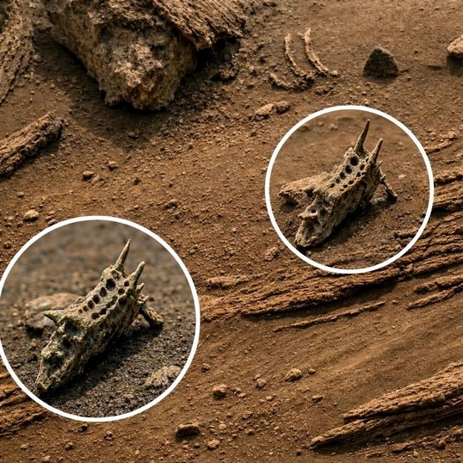
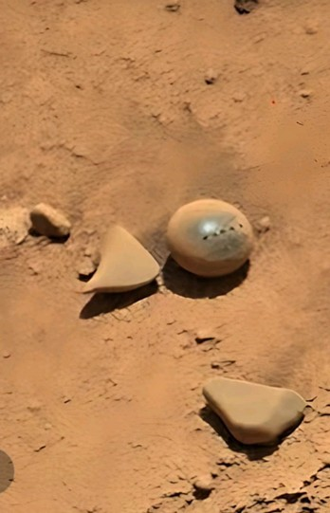
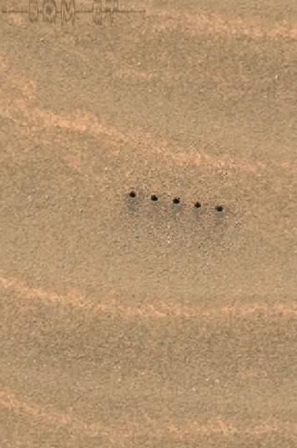
15 · IOoaNeyx
Observation: An angular, protruding form is circled and enlarged.
Hypothesis: A mandible-like component of a mineralized organism.
Alternative: Rock relief, mineral structure, or altered imagery requiring source checks.
Not authenticated anatomy or a fossil. The inset is not a second specimen.

37 · 7BYKUixZ
Observation: A smooth, rounded object appears beside angular fragments.
Hypothesis: A detached pod with associated pieces.
Alternative: Unrelated clasts or an image whose origin and editing require verification.
Symmetry and sheen do not prove an egg, material identity, or authenticity.
Manipulation is not diagnosed here.

08 · lzBcWyJz
Observation: Several small dark marks appear aligned.
Hypothesis: A movement trace or coordinated arrangement.
Alternative: Operational/tool marks, texture, or another nonbiological disturbance.
No object is tracked making the marks. Their scale, timing, and cause are unmeasured.
Figure 7 · Plate C. User-supplied images, resized with existing annotation retained. Mars origin and original image integrity are not certified. Proposed relationships among the objects are unobserved; the panels cannot be assembled into a developmental sequence.
An appealing resemblance must survive an archive and edit-history check before it can become a scientific target. If provenance cannot be recovered, the image may remain illustrative but cannot support a missionspecific discovery claim.
Physics & energy budget
5 PHYSICAL FEASIBILITY IS AN OPEN QUESTION

The unclosed energy budget
The proposed system combines stress transduction, radiation chemistry, information storage, locomotion, and communal return. Each may be described in physical language, but their combination is not thereby a viable organism. A coherent narrative must still close its material and free-energy balances under the actual conditions of the proposed habitat.

Pavailable ^{× η > P}maintenance ^{+ P}repair ^{+ P}movement ^{+ P}copying ^{+ P}losses

Qualitative bookkeeping only. P denotes the relevant rate of energy supply or expenditure; η denotes conversion efficiency. All terms must be defined consistently and measured or bounded. No values, efficiencies, or viability result are supplied here.
A radiation field or temperature variation is not equivalent to usable metabolic power. Reactants must be accessible, products must remain separated long enough to do work, and energy must be coupled to maintained organization. Thermal cycling alone does not provide free work to an equilibrated system; gradients need a rectifying pathway and associated entropy production. Radiolysis can create chemically useful species under suitable conditions, but it also produces losses and damage.
Solvent and kinetics. What medium permits reactions and transport? Are the reactants mobile and persistent under the relevant conditions? A porous texture does not answer either question.
Energy and repair. Can accessible free-energy flux exceed maintenance, damage repair, and proposed movement? Mineral defects may store energy, but do not establish biological capture or sufficient power.
Directional signal. Is the claimed stimulus distinguishable from background and environmental variation? Sensing, transduction, navigation, and energy harvesting require separate demonstrations.
Information and reproduction. What is copied, how faithfully is it retained, and how do variants persist into descendants? Repeated crystal forms are not enough.
No activity, dose, reaction yield, conversion efficiency, maintenance requirement, displacement, or replication has been measured for the pictured objects. Consequently, neither a quantitative viability claim nor a probability of life is justified. A negative usable-energy balance would defeat the stated energy mechanism even if the shapes remained intriguing. Conversely, an energetically feasible reaction network would still not establish life without organization, replication, and heredity.
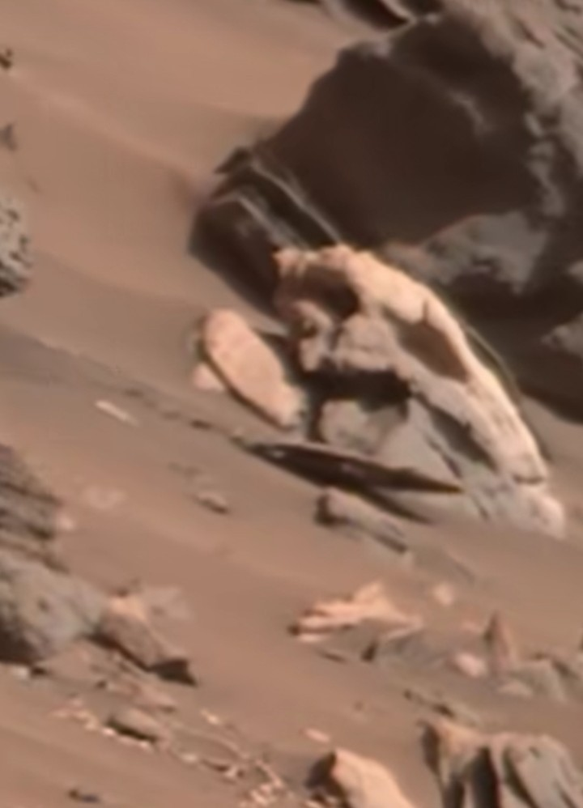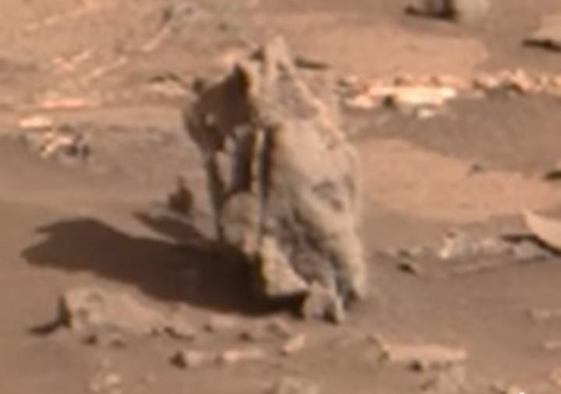
Research workflow
6 FROM IMAGE TO EXPERIMENT

A falsifiable research workflow
Investigation should begin with provenance, not with increasingly elaborate interpretation. Recover original archive files, metadata, edit history, and duplicate relationships. Then identify the same target in registered repeat imaging, with controls for illumination, dust, thermal changes, wind, parallax, erosion, and operational disturbance.
Independent

replication

→

evaluate

specific

mechanisms
Replication,

inherited

variation,

and

contamination

tests
Usable

free-energy

budget,

kinetics,

and

losses
Chemistry,

mineralogy,

textures,

and

isotopes
Registered

repeat

imaging

+

abiotic

controls
Original

raw-image

provenance

and

duplicate

mapping
Figure 4 · Research workflow. A proposed sequence of tests, not a completed study. Instrument availability, spatial resolution, and detection limits must determine the practical protocol. Null results constrain stated mechanisms under tested conditions, not every conceivable form of Martian life.
Chemistry should test mineral phases, redox state, organic material, and isotopic patterns with blanks and contamination controls. A chemical anomaly is not uniquely biological. Mössbauer spectroscopy was carried by the Mars Exploration Rovers; it is not a universal current rover capability. Raman measurements are mission-dependent. Gamma and neutron measurements must be interpreted at their actual spatial resolution, not assumed to resolve tiny individual objects. Atomic-scale tomography and comparable microstructural tests are generally laboratory or samplereturn proposals.
Experiments must then address usable energy, active response, and copying. Reversible stimulus responses should exceed passive controls; directional displacement should survive environmental confounders; inherited variation should persist through replicated tests with material closure. Detection limits and decision thresholds should be preregistered from instrument performance, not invented after a striking image appears.
Predictions & contrary results

6 MEASUREMENT PREDICTIONS
What would challenge the model?
The following tests target individual mechanisms. A contrary result would weaken or reject the specified mechanism within the tested conditions and sensitivity. It would not demonstrate that Mars is universally lifeless. Likewise, a positive result would require independent replication and exclusion of alternatives.
Proposed prediction | Abiotic alternative | Measurement / instrument | Matched control | Result contrary to this mechanism
Orientation / sensing  A repeatable response follows a defined mechanical or EM stimulus. | Rock fabric, passive resonance, perspective, wind alignment. | Calibrated geometry; frequency-response and field measurements; phase identification. | Similar inert clasts under the same stimulus and viewing geometry. | No response beyond passive controls, or coupling too weak for the proposed detector.
Detachment lineage  A specific attached form repeatedly produces a related clast. | Spalling, thermal fatigue, ordinary fracture. | Registered repeat imaging; matching surfaces and material chemistry. | Comparable joints and exposed rock under the same conditions. | Fragments follow ordinary fracture behavior without a distinct developmental sequence.
Pod chemistry Internal changes preserve organized, energycoupled information. | Weathering, cementation, irradiation damage, crystal growth. | Controlled thermal/radiation tests; spectroscopy and laboratory microstructure. | Compositionally similar abiotic materials; procedural blanks. | Changes are fully reproduced by abiotic controls, or destroy rather than copy organization.
Directed movement Displacement persists toward a defined resource gradient. | Wind, settling, thermal creep, dust or imaging artifacts. | Registered stereo/time series with environmental logs and fiducials. | Inert clasts matched for shape, contact, slope, and exposure. | Apparent movement  vanishes after registration or is accounted for by passive controls.
Radiochemical foraging Accessible gradients supply enough usable free energy. | Passive mineral sorting; nonusable radiation energy. | Compositional assays; dose, yield, reactant, transport, and loss constraints. | Unassociated nearby material and mineralogical controls. | No accessible gradient, or energy supply remains below required costs.
Communal return  Objects return directionally and transfer resources. | Passive accumulation and cementation. | Longitudinal tracking; controlled stimulus interruption; material tracing. | Equivalent non-natal aggregates and passive clast fields. | No preferential return, no transfer, or no physically detectable proposed beacon.
Heredity  Organization is copied with persistent variation. | Repeated crystal habit or chemical patterning. | Replicated controlled propagation; serial transfer and material accounting. | Abiotic growth systems; contamination and handling blanks. | No inherited organization beyond repeated external conditions or contamination.
Interpret against preregistered detection limits; an unresolved effect is inconclusive, not confirmation.
Plate D · provenance cautions
OBSERVATION VERSUS INTERPRETATION · PLATE D

Comparison material and attribution
Not every supplied picture belongs in a Martian biological argument.

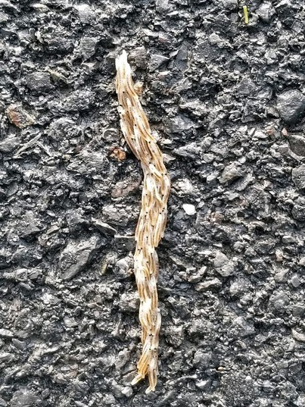
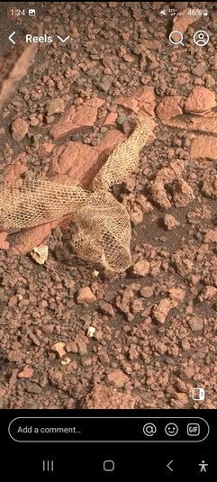
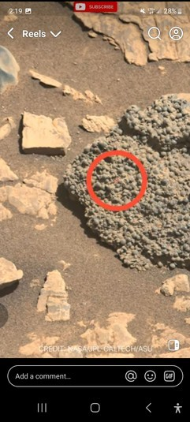
18 · v81RTtXT
Observation: A pale elongate cluster lies on dark, asphaltlike aggregate.
Hypothesis use: Visual comparison only—not a Martian rockworm observation.
Alternative/context: Non-Martian/unverified comparison material.
No species is identified here. No mission metadata connects this image to Mars.

28 · 3ECQxq9y
Observation: Netlike or woven material appears on rubble in a socialmedia screenshot.
Hypothesis: An organized biological structure.
Alternative: Engineered or spacecraft debris requiring operations/material checks.
Interface retained. Mesh appearance does not establish tissue or biological manufacture.

22 · qp0gK0dI
Observation: A nodular surface is shown with a displayed NASA/JPLCaltech/ASU credit.
Hypothesis: Repeated attached forms.
Alternative: Mineral nodules and differential weathering.
Displayed credit is retained, but an original mission file and its metadata are not established.
Figure 8 · Plate D. Resized user-supplied files; no generative modifications. Source interfaces and credits are part of the supplied images, not independent authentication by this report. Comparison imagery and possible debris are not fitted into the life cycle as biological stages.
A reliable archive trail links an image to acquisition and processing records. A watermark, social caption, or familiar color palette cannot substitute for that trail.
Conclusions & corrections
7 CONCLUSIONS AND EDITORIAL RECORD

Imagination with an evidentiary boundary
The rock-worm scenario offers a provocative image of life whose most durable structures would be mistaken for stones: sensory hooda arrays, wind-assisted dispersal, chemically reorganizing pods, radiochemical foragers, and communal recementation. It asks how information, energy capture, and structure might become inseparable within a mineral–organic system.
It does not establish that such a system exists. No living rock-worm, connected developmental sequence, directed movement, reproduction, or viable energy budget has been demonstrated. Geological explanations remain the wellsupported baseline for authenticated Martian concretions and erosional forms, while the supplied images require their own provenance checks. Intrigue becomes science through alternatives, thermodynamics, longitudinal observation, and evidence of copying and heredity—not shape alone.

Substantive editorial corrections
Submitted idea or issue | Editorial treatment in this edition
Liquid helium alongside aqueous history | Removed as a Martian aqueous alternative; water and possible brines retained.
Rover settings combined | Meridiani, Gale, and Jezero separated; Jezero’s explored igneous floor distinguished from sedimentary delta deposits.
Ultrasound / ELF / acoustic terms | Separated mechanical ultrasound, low-frequency elastic motion, and electromagnetic fields.
Preferred orientation and mineral sensors | No measured azimuth claimed; phase-dependent piezoelectricity and signal/noise requirements added.
Wind-driven pebbles and spherical eggs | Transport qualified by unknown thresholds; concretion growth and non-biological rounding alternatives retained.
Defects as metabolism or inheritance | Recast as conjecture; usable energy, copying, repair, and hereditary variation identified as missing.
Radioactive “micro-reactors” | Decay/radiolysis distinguished from fission; speculative reactor abstract excluded from core support.
Foraging and hive behavior | NORM enrichment, directional sensing, beacons, return, and transfer labeled unmeasured.
Static crops as biological sequence | Duplicates/insets distinguished from independent observations; no motion, growth, hatching, or lineage inferred.
Instrumentation and image attribution | Historical, mission-dependent, and laboratory capabilities separated; unverified comparisons and debris not certified as Mars biology.
Presentation and author links | Grammar and hierarchy improved; duplicated ORCID paste removed; profiles separated from literature and endorsement.
Fidelity note: this edition preserves the manuscript’s full conceptual sequence and distinctive terminology in an edited, qualified form. The original submitted text is not reproduced verbatim. No affiliation, credential, peer review, publication status, or institutional endorsement is asserted.
Core references
REFERENCE REGISTER · CONTEXTUAL EVIDENCE

Core references and source strength
These sources support contextual geology or methodological caution, not the proposed organism. Bibliographic details are limited to supplied or checked information.
R1 · NASA/JPL. Mineral in Mars “Berries” Adds to Water Story.
Official mission communication · checked contextual account.
Describes Opportunity’s Berry Bowl analysis, hematite-bearing spherule accumulations, and the concretion interpretation. Does not establish eggs or the chemistry of these uploaded images.
R2 · Bell, J. F., et al. (2022). Geological, multispectral, and meteorological imaging results from the Mars 2020 Perseverance rover in Jezero crater. Science Advances 8(47), eabo4856. Peer-reviewed primary study · contextual geology checked.
First-year explored crater-floor igneous units and aqueous alteration; not an organism report.
R3 · ScienceAlert. Here’s The Truth About That Photo of “Mushrooms” Growing on Mars.
Secondary critical commentary · not primary biological evidence.
Useful for the morphology-only debate. Its misleading spherule-size statement is not adopted.
R4 · Haber, J. T., et al. (2022). Mineralogy of a Possible Ancient Lakeshore in the Sutton Island Member of Mt. Sharp, Gale Crater, Mars, From Mastcam Multispectral Images. Journal of Geophysical Research: Planets.
Peer-reviewed primary study · abstract and metadata checked via OpenAlex.
Publisher full text could not be read. Full-text details: [DATA NOT AVAILABLE]. Only abstract-level contextual findings are used.
R5 · Banham, S. G., et al. (2025). A Burial History of the Sedimentary Succession Preserved in Aeolis Mons, as Recorded by Fracture Networks at Maria Gordon Notch, Gale Crater, Mars. Journal of Geophysical Research: Planets. Peer-reviewed primary study · abstract and metadata checked via OpenAlex.
Publisher full text could not be read. Full-text details: [DATA NOT AVAILABLE]. The publication year is 2025; the DOI contains
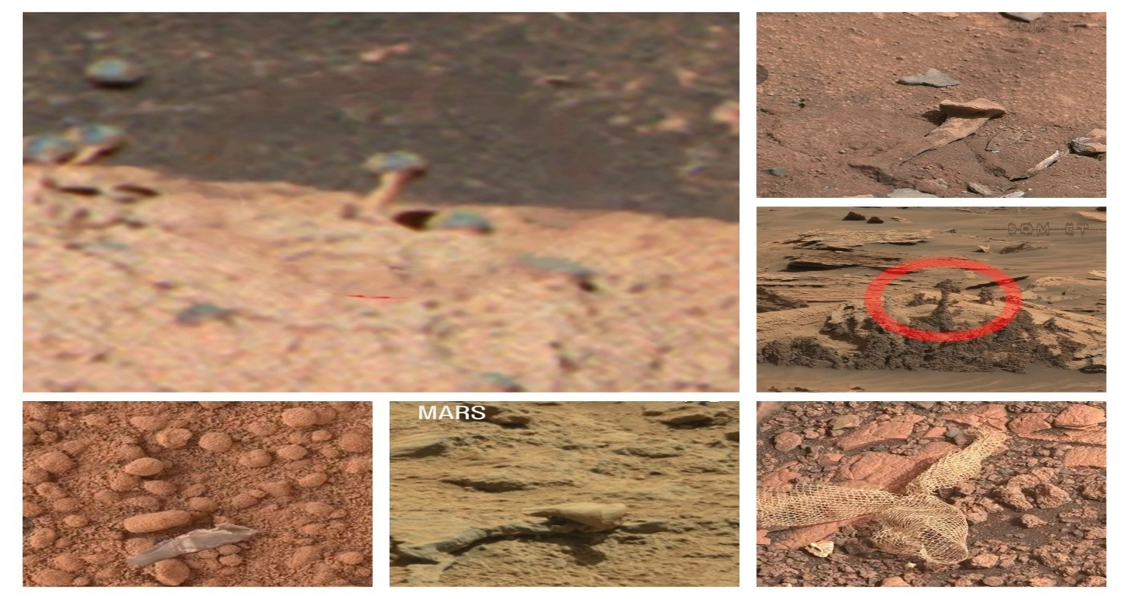
2024. No numerical burial results are imported into this report.
R6 · Ewing, R. C., et al. (2017). Sedimentary processes of the Bagnold Dunes: Implications for the eolian rock record of Mars. Journal of Geophysical Research: Planets.
Peer-reviewed primary study · abstract and metadata checked via OpenAlex.
Publisher full text could not be read. Full-text details: [DATA NOT AVAILABLE]. Used for sand/dune process context, not arbitrary pebble mobilization or an observational chart.
R7 · Baucon et al. (2020). Ichnofossils, Cracks or Crystals? A Test for Biogenicity of Stick-Like Structures from Vera Rubin Ridge, Mars. Geosciences 10(2), 39. doi:10.3390/geosciences10020039.
Peer-reviewed primary comparison · conclusion checked.
Available evidence cannot establish biogenicity or reject the abiotic null; further investigation is encouraged.

Added context sources · R14–R21
R14 · Hassler, D. M., et al. (2014). Mars’ surface radiation environment measured with the Mars Science Laboratory’s Curiosity rover. Science 343, 1244797.
Peer-reviewed primary study · used for the 0.21 mGy/day GCR dose (Figure 11).
R15 · Taylor, G. J., et al. (2006). Variations in K/Th on Mars. Journal of Geophysical Research: Planets 111, E03S06.
Peer-reviewed primary study · global K ≈ 3300 ppm, Th ≈ 0.62 ppm; GRS footprint ≈ 500 km.
R16 · Maurice, S., et al. (2022). In situ recording of Mars soundscape. Nature 605, 653–658.
Peer-reviewed primary study · speed of sound ≈ 240/250 m/s; 20 Hz–50 kHz recordings.
R17 · LaRowe, D. E., & Amend, J. P. (2015). Power limits for microbial life. Frontiers in Microbiology 6, 718. Peer-reviewed review · maintenance power 0.019–4700 × 10⁻¹⁵ W per cell.
R18 · Allwood, A. C., et al. (2020). PIXL: Planetary Instrument for X-ray Lithochemistry. Space Science Reviews.
Instrument paper · ~120 µm X-ray beam.
R19 · Bhartia, R., et al. (2021). Perseverance’s SHERLOC investigation. Space Science Reviews.
Instrument paper · ~100 µm deep-UV laser spot.
R20 · Maurice, S., et al. (2012). The ChemCam instrument suite on the Mars Science Laboratory rover. Space Science Reviews 170, 95–166.
Instrument paper · LIBS spot 350 µm at 2 m to 550 µm at 7 m.
R21 · Klingelhöfer, G., et al. (2003). Athena MIMOS II Mössbauer spectrometer investigation. Journal of Geophysical Research: Planets 108(E12).
Instrument paper · field of view ≈ 1–2 cm.
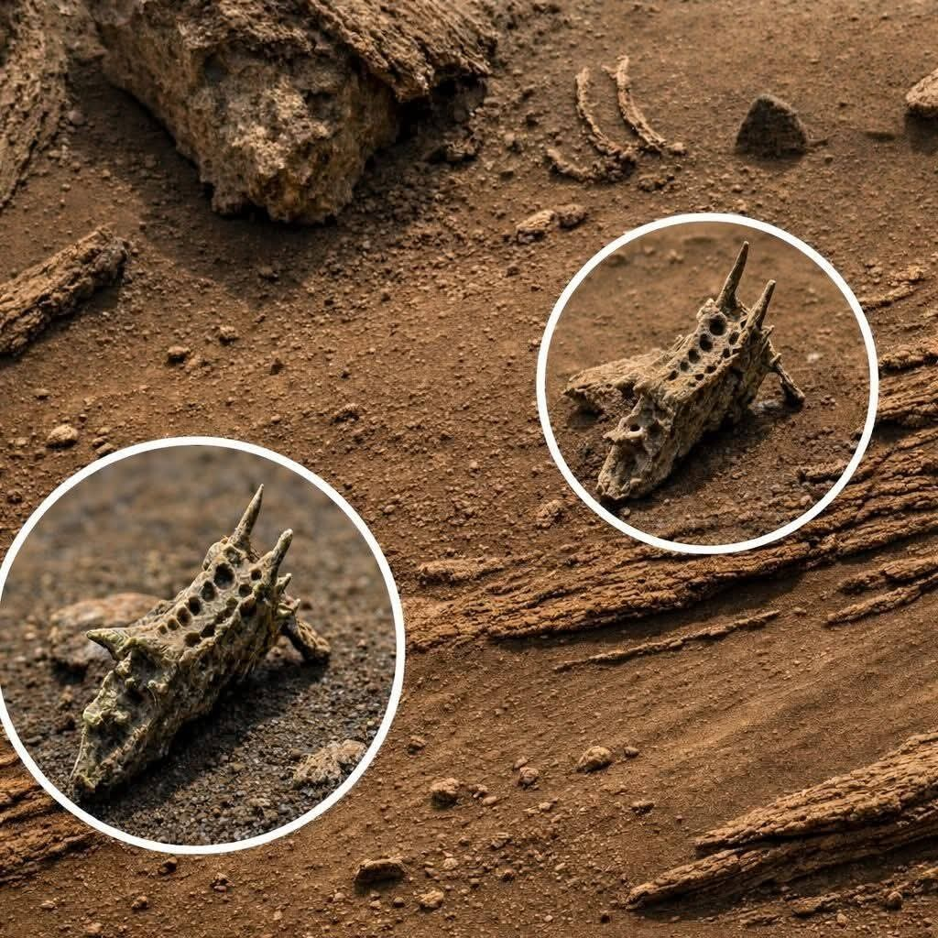

Supplied sources & profiles
REFERENCE REGISTER · RETAINED SUPPLIED MATERIALS

Additional sources and author links
R8–R13 are retained as supplied and were not independently assessed in this edition. Their inclusion is not a finding that they support the rock-worm mechanism.
R8 · Wikipedia. Martian spherules.
Tertiary overview; not a substitute for mission measurements.
R9 · Y-Mars: An Astrobiological Analogue of Martian Mudstone.
Supplied title and DOI; no unchecked findings or author metadata imported.
R10 · A Rock Record of Complex Aeolian Bedforms in a Hesperian Desert Landscape: The Stimson Formation as Exposed in the Murray Buttes, Gale Crater, Mars.
Supplied title and DOI; not independently assessed.
R11 · Marspedia. Radioactive Rarity on Mars.
Wiki source; not a primary object-level energy constraint.
R12 · Evidence for a Large Natural Nuclear Reactor in Mars Past.
Supplied speculative conference abstract; not established reactor evidence and not core support.
R13 · Popular Mechanics. Scientists Believe These Photos Show Mushrooms on Mars. Secondary media account; not independent biological validation.

Author profiles—not research articles
ORCID: the author-supplied profile is linked on the cover. Its public display uses “RichardPiesse” and contributor name “Piesse, Richard.” No affiliation or credential is verified here.
Web of Science: RBQ-6665-2026 is a link supplied by the author. Independent access was blocked by a human-verification challenge; profile content: [DATA NOT AVAILABLE]. Neither profile is evidence for the hypothesis, authorship of cited papers, or institutional endorsement.

User-supplied collage references
Visual materials, not scientific literature or independent samples:
20260109_153623-COLLAGE.jpg
20260109_154044-COLLAGE.jpg
20260109_153735-COLLAGE.jpg
Image manifest · 01–21
APPENDIX · UPLOADED-IMAGE REGISTER

Complete image manifest · 01–21
All entries are user-supplied. Original camera, sol, mission archive ID, physical scale, and edit history: [DATA NOT AVAILABLE]. Descriptions concern visible appearance, not authenticated origin or diagnosis. “Related” and “duplicate family” identify repeated or similar supplied views, not measured biological populations. Source links open the supplied files.
ID / source | Visible  appearance | Handling and limitation
01 · F84iYARC | Sky with multiple bright disks. | Omitted from main plates. Unverified; not evidence for multiple suns.
02 · WyhOfyJv | Annotated pedestal and inset. | Figure 5. Inset repeats one feature; no established function.
03 · jCHT8cWF | Densely nodular matrix. | Figure 5. Chemistry and biological status unmeasured.
04 · 1U4PZoFB | Low-resolution cap-like forms. | Related morphology, not evidence  of life or  measured dimensions.
05 · Xh0XgeRD | Slender pedestals and caps. | Figure 5. Lowresolution appearance; no measured orientation.
06 · 2lMg2nWf | Layered material with knobs. | Unverified context; protrusions not assigned a biological stage.
07 · pPyBmINi | Layered outcrop and protrusions. | Figure 6. Geological alternatives remain open.
08 · lzBcWyJz | Aligned dark marks. | Figure 7. Tool/operatio nal marks possible; no track-making observed.
09 · mN772l1j | Angular jaw/skull-like | Resemblance  is not

 | form. | anatomy; pareidolia caution.
10 · uxRm50P6 | Arch-like eroded form. | Unverified rock-like appearance, not a biological structure.
11 · 382bRIqK | Upright weathered form. | No authenticated setting, scale, or material identity.
12 · bQiTEtX7 | Slab with winding ridges. | Figure 6.  Shape alone does not show locomotion.
13 · TeCpzAja | Perforated irregular rock. | Figure 6. Cavities not established cells or biological channels.
14 · EK82A60D | Rounded weathered mass. | Unverified; roundness not a  development al diagnosis.
15 · IOoaNeyx | Annotated horned/angular object. | Figure 7. Source verification required; not  authenticated  fossil evidence.
16 · XbkHbWe0 | Glossy sphere and angular pieces. | Related to 37; not an independent biological confirmation.
17 · bm2ifay8 | Phone screenshot; circled sphere. | Sphere-family duplication caution; annotation is not evidence.
18 · v81RTtXT | Pale cluster on asphalt-like aggregate. | Figure 8. NonMartian/unve  rified  comparison; no species identification.

19 · Yhj3uYFc | Mixed caps/fragments/ netting collage. | Mixed material, not a sampled population or  linked sequence.
20 · wKBpweoV | Six-panel spheres/rocks collage. | Not independent repeat imaging or a time series.
21 · tO22NWDT | Six-panel knobs/rocks collage. | Panel order does not establish a life-cycle sequence.

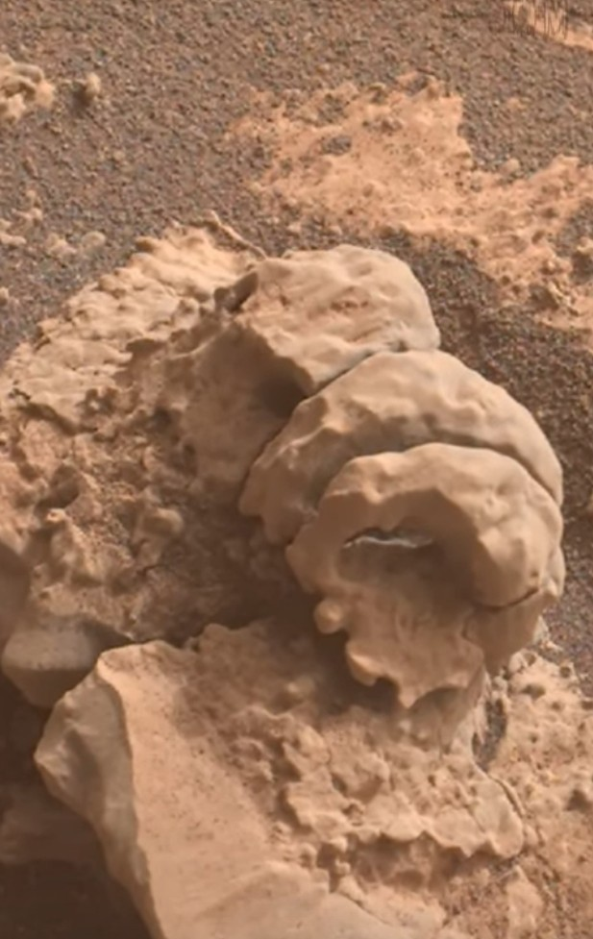

Manifest summary
Grouping the 41 supplied files by visible form (from the descriptions above) shows how the life-cycle stages are illustrated. Twelve files appear in Plates A–D; the other 29 are related views, crops, duplicates or unplaced material. Large families such as caps and nodules mostly repeat a few scenes, so their counts are not population sizes.
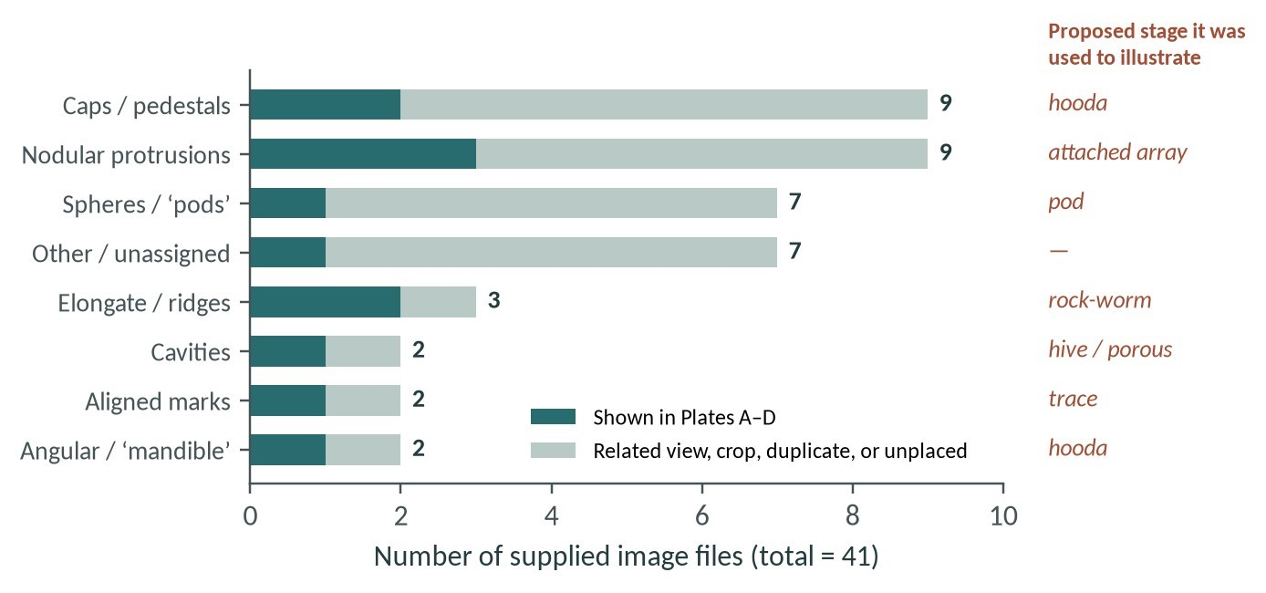
Figure 13 · Supplied images by visible-form family. Editorial classification from the manifest descriptions (01–41). Counts are files, not independent objects; the right-hand column names the proposed stage each family was used to illustrate.
Image manifest · 22–41
APPENDIX · UPLOADED-IMAGE REGISTER

Complete image manifest · 22–41
Continuation. The same global metadata limitations apply: [DATA NOT AVAILABLE] for original camera, sol, archive ID, scale, and edit history. The collection is a set of supplied files, not an established count of independent objects or observations.
ID / source | Visible appearance | Handling and limitation
22 · qp0gK0dI | Nodular screenshot with displayed credit. | Figure 8. NASA/JPL-Caltech/ASU credit retained; original mission file not established.
23 · 25AhHoi3 | Textured nodular close-up. | Related morphology; not independent chemical or biological verification.
24 · LuDtcF8K | ScienceDawn screenshot; elongated rock. | Displayed “MARS” label is not authentication.
25 · rTVXN65m | Som ET screenshot; aligned marks. | Related to 08; not an independent movement trace.
26 · gvkfLspt | Social screenshot; layered outcrop/knobs. | Related appearance; source metadata required.
27 · K7HQR1WZ | Social screenshot; perforated rock. | Related to 13; not independent biological evidence.
28 · 3ECQxq9y | Social screenshot; netlike material. | Figure 8. Possible engineered/spacecraft debris; interface retained.
29 · TDOwoD7X | Screenshot; dense rounded protrusions. | Nodular duplicate family; not an independent population sample.
30 · mmNlM1Hy | Screenshot; nodular outcrop. | Related view in nodular family; duplication caution.
31 · NVpNPiof | Cropped spherical protrusions. | Duplicate-family crop; not new observational evidence.
32 · MxiXTK1q | Screenshot; slender pedestals/caps. | Related to 05 family; no temporal change established.
33 · MyenQyVr | Crop of pedestal scene. | Same-scene family; not a new specimen or stage.
34 · rPFXSovl | Screenshot; smooth sphere. | Sphere family; no composition or reproductive role established.
35 · aQBn5OGb | Duplicate smooth-sphere screenshot. | Not independent evidence; provenance remains unresolved.
36 · yafwwn7M | Crop of smooth sphere. | Same family; enlargement cannot establish internal structure.
37 · 7BYKUixZ | Glossy sphere and angular fragments. | Figure 7. Related to 16; source/edit verification needed.
38 · YoTJZonS | Cap-like forms with red arrow. | Annotation points to appearance, not validated biology.
39 · s0dMZtxL | Enlarged small cap-like form. | Enlargement is not a new observation.
40 · WKrwoIQX | Screenshot; pedestal/cap scene. | Related family; no linked development established.
41 · 0KLGyyel | Crop of cap/pedestal scene. | Same-scene family; not an independent stage transition.
Closing evidence statement. The report uses supplied pictures as visual prompts, contextual literature as geological support, and diagrams as explicitly labeled models. No image or cited source is represented as demonstrating the proposed lithic biosphere.

Synthesis: the cycle as a set of testable couplings
Each proposed stage is tied to a real Martian process, and each link implies a measurement that could fail (Figure 14). The instruments that could make those measurements work at very different scales (Figure 15). Rover micro-analysis can resolve a millimetre spherule; orbital gamma-ray data cannot resolve anything smaller than hundreds of kilometres.
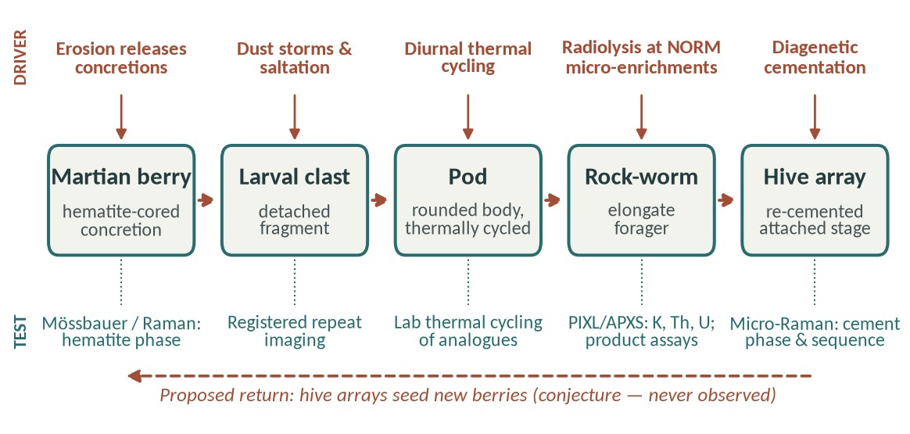
Figure 14 · Stage–driver–test map. Top: the Martian process each stage is proposed to exploit. Bottom: a discriminating measurement for that link. Dashed arrows are conjectured transitions; none has been observed.
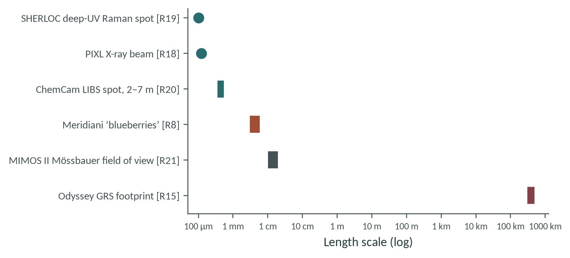
Figure 15 · Measurement scale versus target scale. Analysis spot or footprint of each instrument compared with Meridiani spherules. Sources: R8, R15, R18–R21. Mössbauer was carried by the Mars Exploration Rovers, not current rovers.

